

FARM MANAGEMENT AFRICA ASSET MODULE

STUDY GUIDE

T: +27 21 874 1047



 [sales@donkerhoekdata.co.za](mailto:sales@donkerhoekdata.co.za)  [support@donkerhoekdata.co.za](mailto:support@donkerhoekdata.co.za)



 Simondium Guild - R45 - Simondium

[www.donkerhoekdata.co.za](http://www.donkerhoekdata.co.za/)





# Who is Donkerhoek Data?

It all began in 1982 on the farm Donkerhoek, situated in Simondium. Farmer Robert Koch developed and introduced specialized agricultural software to the industry.

Today this innovation still continues, making Donkerhoek Data an industry-acknowledged service provider to more than 1,000 clients. Donkerhoek Data also offers comprehensive hardware services.

# The Payroll Africa User Manual

Do consult our extensive user manual. It offers information on using Payroll Africa’s program functions and has search facilities.

This symbol indicates which section in the manual has more information on the particular topic. Updates will be made available on our web page.

# Avoid high bank charges with

We advise clients to use Paysoft for electronic payment transfers. You pay a ﬁxed price per transaction with Paysoft. Transaction fees are lower than what the banks charge and there are no monthly or hidden costs.

Paysoft offers tight security and is just as safe as electronic banking. You can also use it to pay your debtors. An appointed staff member will gladly give a demonstration at a time that suits you.

# Other Donkerhoek Data Products

Farm Management Africa

Spray, fertilizer, record keeping and reports, pest monitoring, vehicle register, GlobalG.A.P., Nature’s Choice, IPW, IPM points.

Income Module

Speciﬁc income per block can be allocated.

Payroll Africa

User-friendly Payroll (Wages and Salaries) for the farm, cellar, or business. Additional hardware that handles time and attendance, as well as piecework, can be incorporated.

FARM MANAGEMENT AFRICA ASSET MODULE

STUDY GUIDE

**Asset Module**

**ASSET MODULE HOME SCREEN**

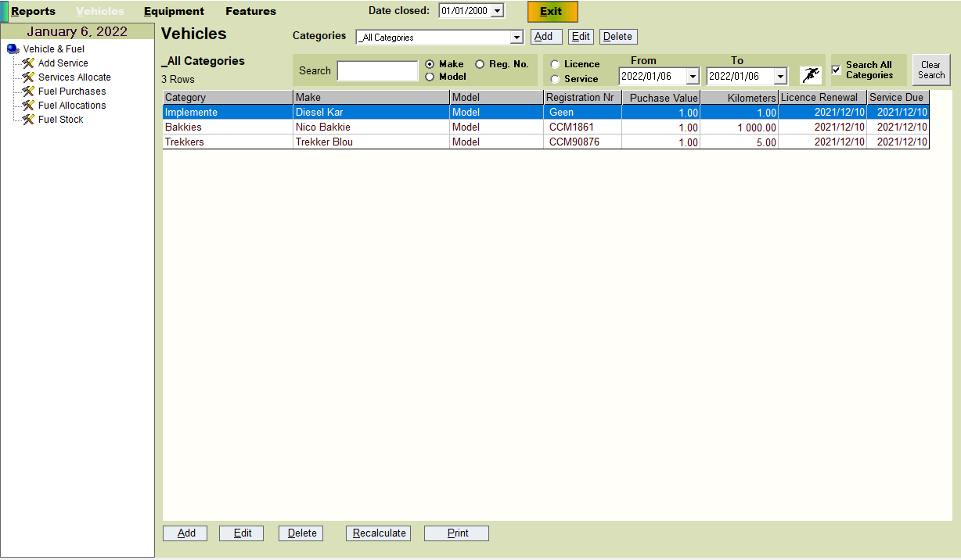

* **Date closed:** The system will block you from capturing any transaction/s, previous to this date. Select the applicable date.
* **Search:** Select “Make/Model or Reg. No.” The vehicle list will filter according to what has been typed in, and search according to what you have selected.
* **Clear Search:** Clears any filters to All Categories.
* **From & To Licence and Service:** To view which licenses and Services are due, filter according to the date range**.** When opening the program, a reminder will populate on the chosen date.
* **Add/Edit/Delete:** Select one of these options to Add/Edit, or delete a vehicle in the selected category.
* **Recalculate:** Refreshes the tables in the background.
* **Print:** Print the list of vehicles, according to your filter/s.

**Adding a Vehicle Category**

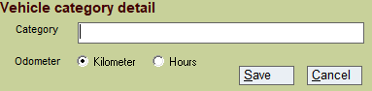

* You can add/edit or delete a Vehicle category.
* When setting up a category, you must choose whether the vehicle category works in kilometres or hours.
* Example of category: Tractors and odometer setup will be Hours.
* After setting up a category, click on Save. It will be available in the drop-down list to choose from when setting up the vehicles in the selected category.

**Adding new vehicle**

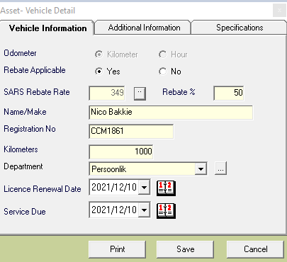

* Under setup new vehicle, 3 tabs will be visible > Vehicle information / Additional Information and Specifications.
* **Odometer:** Completed automatically, as per the vehicle category setup.
* **Rebate Applicable:** Select if it is a rebate-applicable vehicle or not. Once Yes is selected, the SARS rebate rate will appear, as well as the Rebate %.
* **Name/Make:** Type in the name/description of the vehicle.
* **Registration No:** Type in the registration number of the vehicle.
* **Kilometers/Hours:** Type in the kilometres or hours of the vehicle. Please note > that once you start allocating fuel to the vehicle, the kilometres/hours amount entered must always be more than what was previously entered.
* **Department:** Add different departments, under which the vehicle can fall.
* **Licence Renewal Date:** Enter the date. When opening the program, a reminder will populate on the chosen date.
* **Service Due:** Select a date. When opening the program, a reminder message will populate, reminding you of any services.
* **Print:** Prints all the details of the vehicle setup.
* **Additional Information** and **Specifications** are not compulsory options. These tabs are only used for extra information.

**Services Section**

**Add Service**

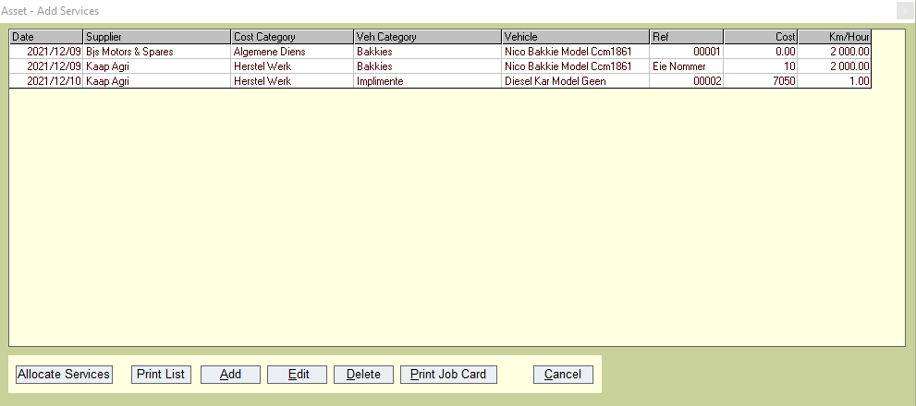

* **Add/Edit and Delete:** Adding a new service transaction, or editing/deleting the transaction.
* **Print List:** Print the current transaction list of services, listed on the screen.
* **Print Job Card:** Print a job card for the specific transaction details.
* **Allocate Services:** Shortcut button to the Service Allocate screen, used to allocate your service transactions.

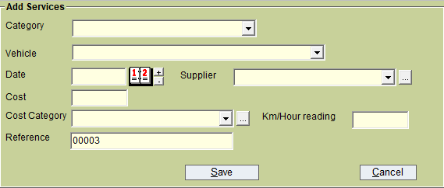

* **Category:** Select the vehicle category to populate the vehicle list.
* **Vehicle:** Select the applicable vehicle for the service transaction.
* **Date:** Select the date of the service transaction.
* **Suppier:** Select/Setup a supplier, for the service.
* **Cost:** Type in the cost of the service. Alternatively, you can start with a 0 figure.
* **Cost Category:** Select/Setup a cost category, for the service transaction.
* **Km/Hour reading:** Type in the km/hour reading of the selected vehicle.
* **Reference:** Type in a reference or use the auto-generated number already completed.

**Service Allocate**

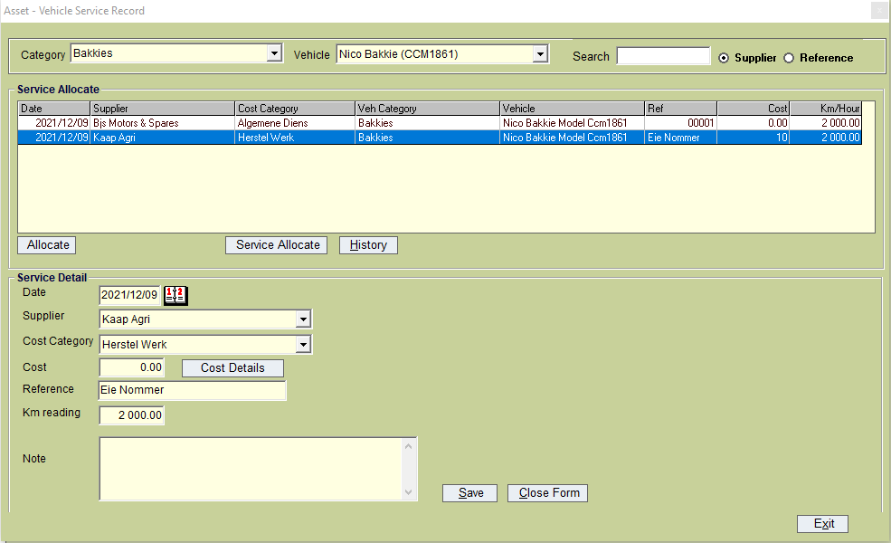

* **Category:** Select the vehicle category.
* **Vehicle:** Select the vehicle you want to allocate the service to.
* **Search:** If the service transaction list is long, you can search according to the supplier, or reference.
* **Service allocation:** Click on the specific transaction line you want to allocate, then click the Allocate button. Details will automatically be filled in at the bottom of the screen. You can enter the cost total and note (if applicable), then click Save.
* **Cost Details button:** You can click on the Cost Details button to fill in more details relating to the total cost.
* **History Button:** Once you have selected the vehicle at the top, you can click on the History Button to view the history transactions for the selected vehicle and print the list as displayed.
* **Service Allocate Button:** Click on the service allocate button next to History to view any open transactions, which can be allocated towards the selected vehicle.
* You can click on the History button, select a transaction, then edit a transaction and save it again.

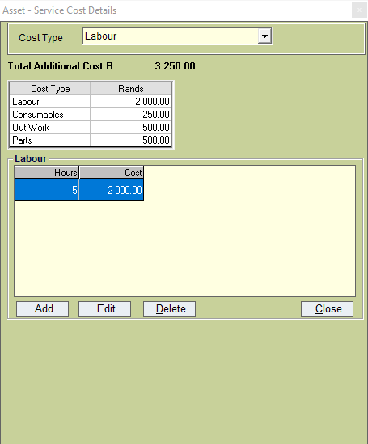

* **Labour:** Type in the hours and the cost or hours and the rand per hour, total cost will be calculated.
* **Consumables:** Type in the name of the consumable, as well as the price. You can add multiple consumables.
* **Out Work:** Type in the supplier, the description of the Outwork, and the price. You can add multiple Out Work transactions. Example: When sending a part to a supplier.
* **Parts:** Type in the part name and price. You can add multiple parts.
* Click on the Close button once you have entered all details.
* Costs for this service transaction will be added and displayed under Cost.
* Please note > You can edit the cost type details and prices.

**Fuel Purchases**

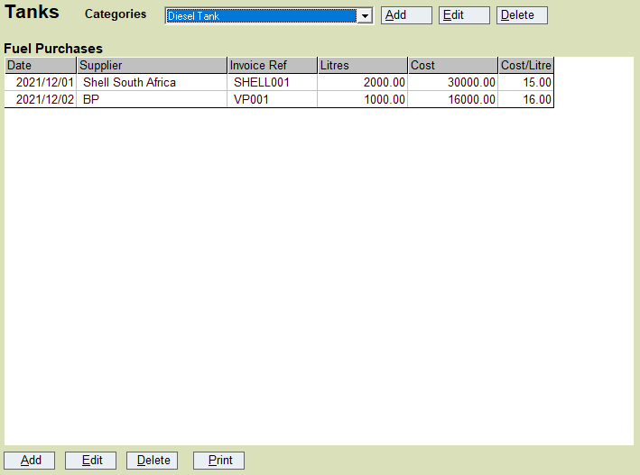

* First a fuel tank must added. (see steps below).
* When making a fuel purchase, select the tank, then click Add (at the bottom left of the screen), to add the new purchase.
* You can edit or delete a purchase.
* **Print:** Select the tank and click on print. The list of purchases displayed on the screen will print to Excel. See the example below.

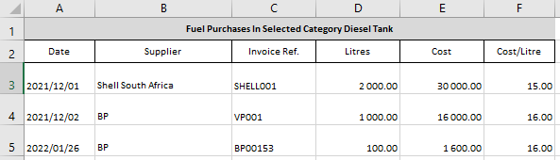

**Add New Purchase**

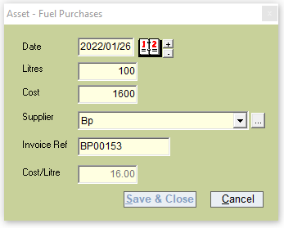

* **Date:** Select a purchase date.
* **Litres:** Type in the number of litres purchased.
* **Cost:** Type in the cost.
* **Supplier:** Add a supplier, or select from the drop-down list.
* **Invoice Ref:** Type in reference.
* **Cost/Litre:** Automatically calculated.
* **Save & Close:** To save and close the purchase.

**Add New Fuel Tank**

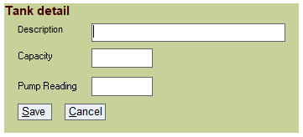

* **Description:** Add the name of the fuel tank.
* **Capacity:** Add the number of litres the tank holds.
* **Pump Reading:** When using a pump reading, you can enter the reading in this field. Otherwise, do not complete this field. Under Fuel allocations, you can use the pump reading option or type in the amount of fuel used.
* If you use the Pump Reading option, you will need to fill in the new reading each time, for the program to work out the fuel amount used, for the specific vehicle, under Fuel Allocations.

**Fuel Allocations**

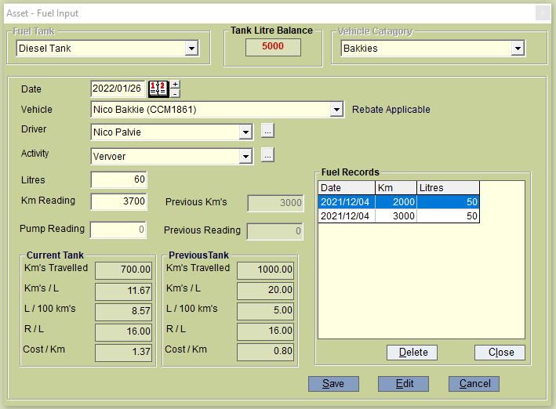

* **Fuel Tank:** Select the fuel tank you wish to use, for this specific allocation.
* **Tank Litre Balance:** The amount of litres available, for this specific tank.
* **Vehicle Category:** Select the vehicle category you want to allocate fuel towards.
* **Date:** Select the fuel allocation date of the vehicle.
* **Vehicle:** Select the vehicle, you want to allocate fuel towards.
* **Rebate Applicable/Not Rebate Applicable:** This Will display next to the vehicle (as set up under the vehicle setup).
* **Driver:** Select the driver, or add a new driver.
* **Activity:** Select the activity, or add a new activity.
* **Litres:** Add the number of litres, thrown into the specific vehicle.
* **Km Reading:** Type in the kilometre or hour reading of the vehicle selected at the time of fuel allocation.
* **Previous Km’s:** The previous km’s or hours will display, for the vehicle selected.
* **Please note** > Remember that the new Km Reading should always be more than the previous km reading.
* **Pump Reading:** Type in the current pump reading for the fuel allocation. When no litres are added, the system will automatically calculate the reading by using the current and previous readings.
* **Previous Reading:** Displays the previous pump reading.
* **Current Tank & Previous Tank**: This section displays extra information for the user to view and monitor.
* **Fuel Records:** To navigate to this screen, select the vehicle category and vehicle, and click on edit. The Fuel Records frame will display all the previous fuel allocations for the selected vehicle. Here you can delete allocations and recapture them if needed.

**Fuel Stock**

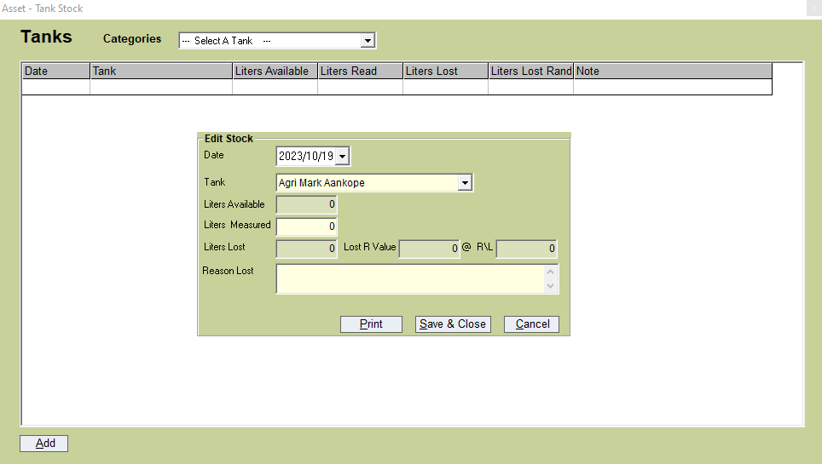

* **Date:** Add the date of the fuel stock take.
* **Tank:** Select the tank you want to do the stock take on.
* **Liter Available:** Displays the litres available for the tank selected.
* **Liters Measured:** Type in the liters you measured for the tank.
* **Liters Lost/Lost R Value & @ R/L:** All 3 fields calculations will automatically be calculated.
* **Reason Lost:** Type in the reason why the litres were lost.
* **Print:** Print the stock take.
* **Save & Close/Cancel:** Click Save & Close to save the stock take, or cancel the stock take.

**Features**

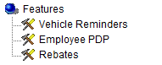

**Vehicle Reminders**

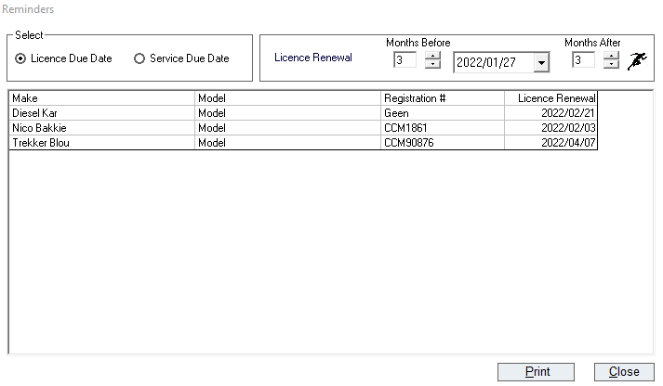

* Under the setup of each vehicle, you can set the License and Service due date as a reminder. When opening the program, a reminder will pop up on the selected date chosen.
* Under Features you can view the reminders, and print the reminders for License and Services.
* By using the filter at the top right, you can view due dates before or after the set date. Type in the months if you wish, and click on the run button.

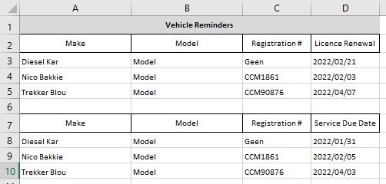

**Employee PrDP**

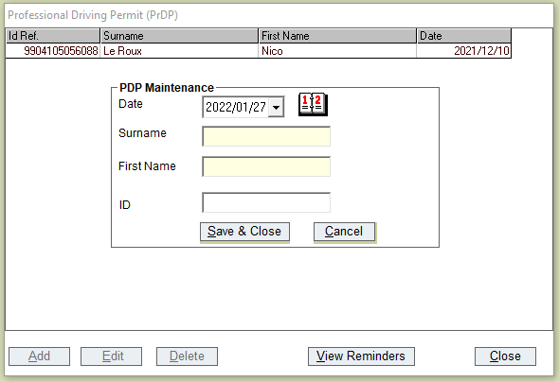

* You can set reminders for employees' Professional Driving Permits (PrDP). When opening the program, a reminder will populate on the chosen date.
* Click on Add, and fill in the necessary details.
* **Date:** Select the date the reminder should populate.
* **Surname and Name:** Type in the details of the employee.
* **ID:** Type in the ID number of the employee.
* Save & Close or Cancel setup.

**Rebates**

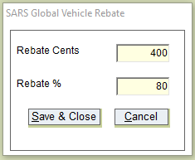

* **Rebate Cents:** Type in the applicable rebate cents deductible per kilometre, as set by SARS.
* **Rebate %:** Type in the % you can claim (only used on the Rebate Report). Only 80% of the eligible litres is allowed for the calculation of the refund currently.

**Equipment**

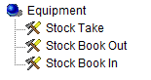

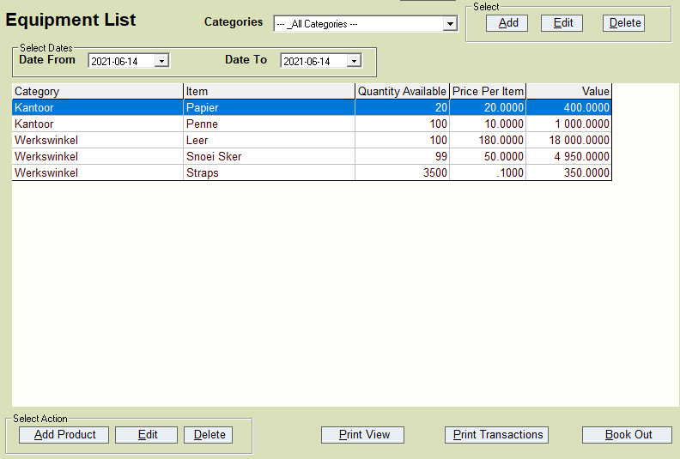

* When opening the Equipment Section, you first have to set up different categories. Click on the Add button next to the Categories drop-down, and type in the name. You can add multiple categories.
* To add equipment under each category, select the category, and click on Add Product (at the bottom left), to add new equipment.
* You can add/edit, or delete a product/equipment.
* **Print View:** Prints the list currently displayed, or filtered.
* **Print Transactions:** By selecting/clicking on an item, you can click on print transactions. An Excel report will be generated with the usage history of that item.
* **Book Out:** Shortcut to book out items to an employee.

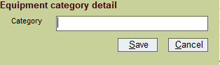

* To add a category name, click on add, and type in the appropriate category name.

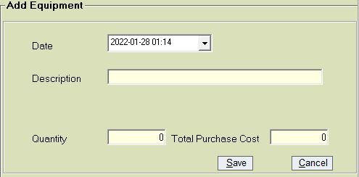

* To add new equipment, select the date.
* **Description**: Add a description for this entry.
* **Quantity:** Fill in the quantity of the item you have in stock.
* **Total Purchase Cost:** Fill in the total cost of all the items you have in stock.

The unit price will automatically be calculated.

**Stock Take**

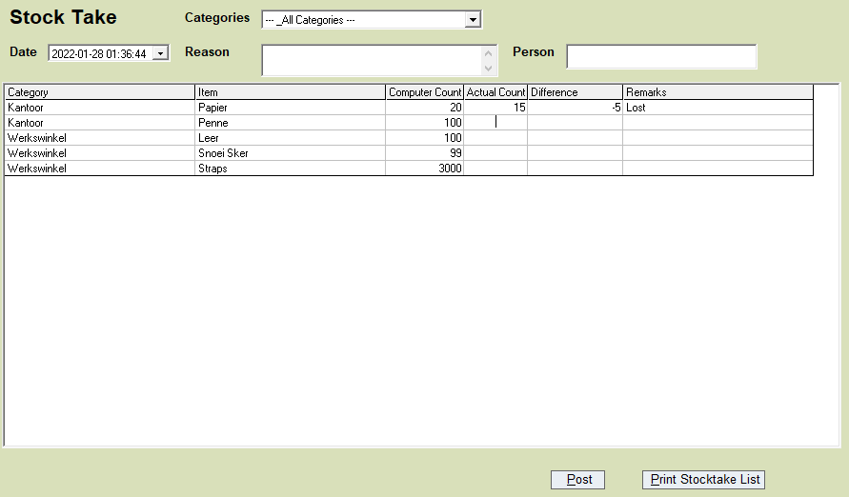

* Click on the stock take option, to do a stock take on all items in their different categories.
* **Date:** Select the date of the stock take.
* **Categories:** You can choose All Categories or a specific category.
* **Reason:** Type in the reason for the stock take.
* **Person:** Type in the person responsible for doing the stock take.
* In the Actual Count column, you can enter the number of items available in stock. The difference will be calculated, and you can type in a reason for the difference.
* **Post:** Click on the post button to save stock take entries.
* **Print Stock Take List:** Prints an empty items list, for you to complete.

**Book Out Equipment**

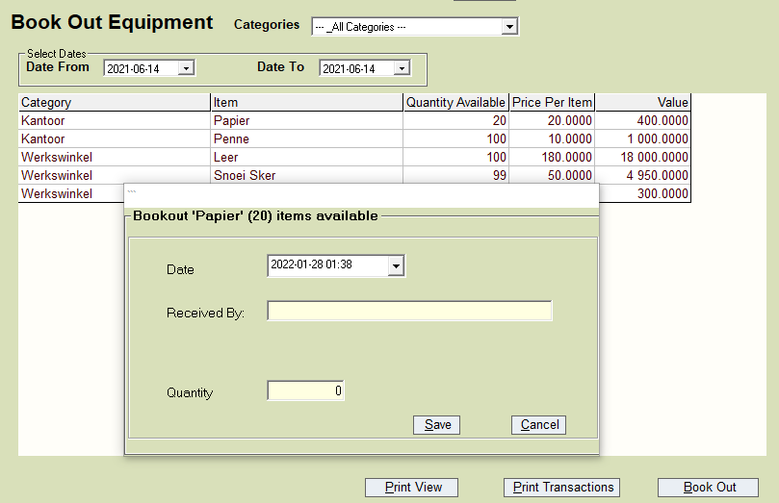

* Select the Book Out Equipment option, if you want to allocate items towards an employee.
* When opening the book out equipment option, a list of items for the categories is displayed.
* Click on the specific item you want to book out and click on the Book Out button (bottom right). The book-out screen for the item will populate.
* **Date:** Select the date for the book out for the item.
* **Received By:** Type in the name and surname of the employee booking out the items.
* **Quantity:** Type in the quantity of the items being booked out.
* Save the transaction. The number of items will then be subtracted from the total items available.

**Book In Equipment**

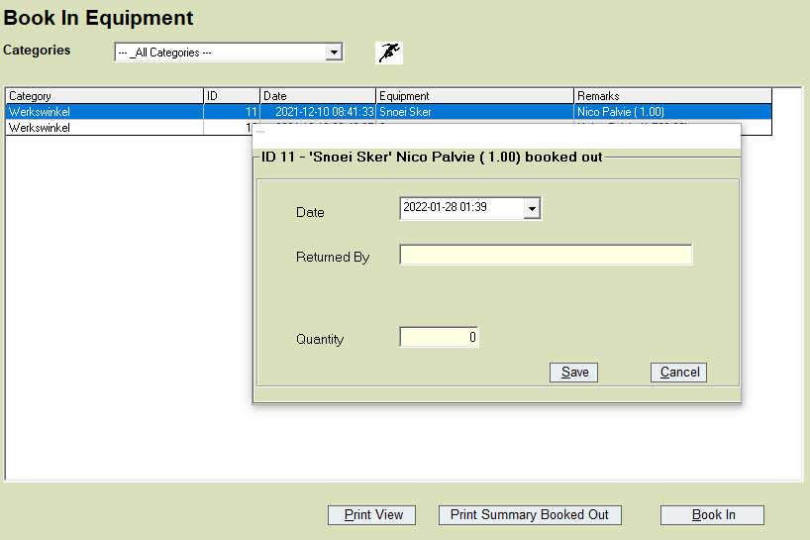

* When items are brought back, they need to be booked in. Click on the ‘Book in Equipment’ option.
* **Categories:** Select the category under which the items fall, or select All Categories.
* The List displayed will reflect all the items that are currently booked out. The quantity, and the person who booked the items out, will also be displayed.
* Select the item being booked in, and click on Book In at the bottom right.
* **Date:** Select the date the item is booked in.
* **Returned By:** Type in the name and surname of the employee who returned the item.
* **Quantity:** Type in the quantity of the item being returned, and click on Save.
* Once saved the transaction line will disappear, if all the items that have been booked out, are booked in again. If not, the list will display the items still outstanding, as well as the quantity.

**Reports**

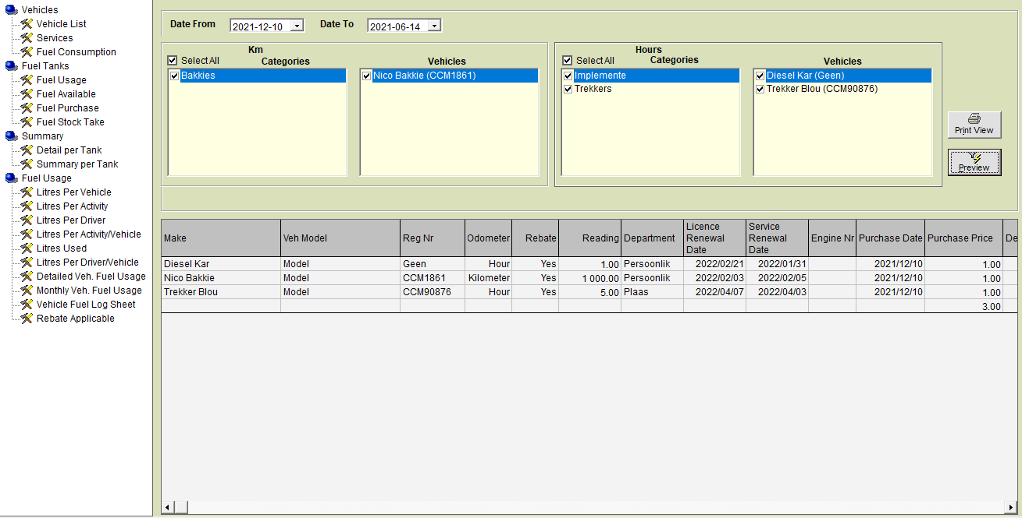

* On the reports screen you have multiple reports to choose from at the left of the screen.
* Select the report you wish to use. Select your from and to date at the top.
* You can filter on KM vehicles and on HOUR vehicles to generate the report.
* You can select multiple vehicles or specific vehicles to generate a report.
* Once filtered, click on the preview button to generate a report at the bottom of the screen.
* To print the report generated, click the Print View button to print the report to Excel.

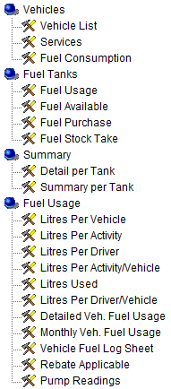

**Additional Information regarding Diesel Rebate & SARS**

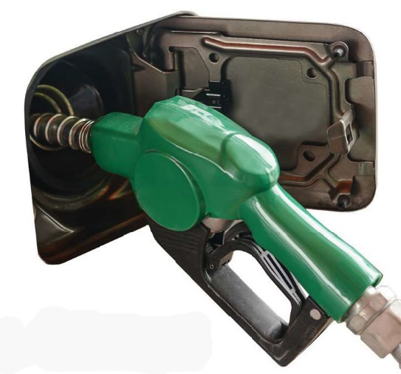The diesel rebate is a diesel refund system. It is a tax relief made available for various activities in the farming, mining and forestry sectors among others.

The intention is to lighten the burden carried by local industries that must compete in the international sector where for e.g. many farmers receive subsidies and other forms of protection. It is also intended as a relief offered on vehicles that do not necessarily utilise the public roads networks since they primarily work in designated areas, for example on farms. The Diesel Refund Scheme is currently administered through the VAT system in terms of the Customs and Excise Act.

This rebate provides full or partial relief from the General Fuel Levy and the Road Accident Fund levy. As of 1 April 2020, the General Fuel Levy increased to 355 cents per litre; and the Road Accident Fund levy increased to 207 cents per litre.

A farmer qualifies for a rebate on 80% of his lawful use in terms of the qualifying litres. This would be litres used for the primary farming activities and would exclude diesel consumed for personal and private use. Farming enterprises are entitled to a diesel rebate in respect of diesel that is physically delivered to the premises of the farm of a qualifying user. Many farmers have been claiming the rebate even when diesel is purchased at other outlets for farming activities. However, a Supreme Court of Appeal judgement made in November 2019 provided guidance on the Act, finding that a qualifying taxpayer may only claim a rebate for the diesel fuel stored and used on its own premises.

**HOW DO I QUALIFY FOR A REBATE?**  
In order to qualify for a diesel rebate:

* It is necessary to firstly be registered as a VAT vendor.
* You must then apply for registration for the diesel rebate with SARS. The form to be completed is a VAT101D.
* In order to qualify for the rebate and be able to claim the rebate back, the onus is on the farmer to prove the amount of fuel consumption.
* All relevant documentation relating to diesel purchases must be kept.
* Logbooks must be maintained. This will require that the farmer completes a schedule listing the activities that qualify for the rebate as well as the diesel usage per activity.

**GENERAL**  
It is important for farmers to understand that the diesel rebate is a special concession being made. SARS officials are always looking out for those who are abusing the system and using it fraudulently. It is to the benefit of the broader farming sector that we respect the legislation and keep our slate clean and honourable.

The diesel rebate is one of the only benefits farmers receive from the government so we should strive to keep records that are beyond suspicion.

