


FARM MANAGEMENT AFRICA COSTING MODULE

STUDY GUIDE

T: +27 21 874 1047
sales@donkerhoekdata.co.za support@donkerhoekdata.co.za
Simondium Guild - R45 - Simondium
www.donkerhoekdata.co.za



Who is Donkerhoek Data?
It all began in 1982 on the farm Donkerhoek, situated in Simondium. Farmer Robert Koch developed and introduced specialized agricultural software to the industry.

Today this innovation still continues, making Donkerhoek Data an industry-acknowledged service provider to more than 1,000 clients. Donkerhoek Data also offers comprehensive hardware services.

The Payroll Africa User Manual
Do consult our extensive user manual. It offers information on using Payroll Africa’s program functions and has search facilities.

This symbol indicates which section in the manual has more information on the particular topic. Updates will be made available on our web page.

Avoid high bank charges with
We advise clients to use Paysoft for electronic payment transfers. You pay a ﬁxed price per transaction with Paysoft. Transaction fees are lower than what the banks charge and there are no monthly or hidden costs.

Paysoft offers tight security and is just as safe as electronic banking. You can also use it to pay your debtors. An appointed staff member will gladly give a demonstration at a time that suits you.

Other Donkerhoek Data Products
Farm Management Africa
Spray, fertilizer, record keeping and reports, pest monitoring, vehicle register, GlobalG.A.P., Nature’s Choice, IPW, IPM points.

Income Module
Speciﬁc income per block can be allocated.

Payroll Africa
User-friendly Payroll (Wages and Salaries) for the farm, cellar, or business. Additional hardware that handles time and attendance, as well as piecework, can be incorporated.

FARM MANAGEMENT AFRICA COSTING MODULE
STUDY GUIDE

Costing Module Setup

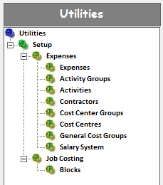

- Expenses: Setup any expense you may have on the farm (from electricity to employee bonuses etc.) If you are using our spray and fertilizer module, the instructions will automatically import to this module. Description & Type – may have the same description name. When allocating expenses, the Type to choose from will be available in the dropdown list.
- Activity Groups: Set up all the activities you may encounter on the farm. (for example, pruning, painting, etc.)
- Activities: Select the activity group. Enter a description and code for the activity. (If using Job Costing in Payroll, use the same activity code, as set up in Payroll under the piecework categories)
- Contractors: Set up your contractor's names only. (These contractors are not reflected in your payroll program)
- Cost Centre Groups: All the places on the farm where workers can perform their work/tasks, for example, houses, dams, roads, pack shed, etc.) This can also include “Electricity/Water/Bonus” and other relevant items. (Do not set up the farm’s blocks, as they will import automatically from the main module.)
- Cost Centres: Select the cost centre group and add more detail under the description if needed.
Remember: The Block name or Cost Centre name will be the heading on your reports. All the costs allocated will be reflected under this name.
- General Cost Groups: Groups that expenses may fall under. You will find a “Copy” function at the Expenses option, which allows you to copy expenses that are already set up, over to your General Cost Groups. (The General Cost Group name will print on the Cost Centers and blocks report under the activity heading)
- Salary System: Indicates the path to where your payroll program is allocated, for example, C:\Africa\PA1. The costing file will be imported from this path.
- Job Costing (Blocks): For Job Costing users in Payroll. At this option, you will link your blocks with your blocks in Payroll by using the same code as set up in Payroll under the piecework categories.
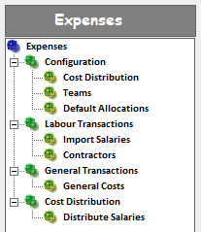

- Cost distribution: Grouping of blocks and cost centres. You will be able to select these groups under Allocate Distribution when you allocate the employee's hours under Distribute Salaries. The groups can be changed at any time.
- Teams: Set up different teams that are used when allocating hours to employees, under Distribute Salaries. These employee groups can be changed if needed.
- Default Allocations: Setup workers that always do the same activity on the same block/cost center. If hours are imported from Payroll and not allocated, the system will default to this setup.
- Import Salaries: Import the Payroll file that was created, when you ended your period in the payroll program.
Contractors

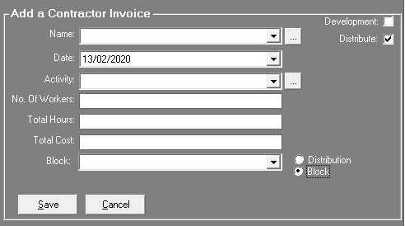

- Name: Choose a contractor from the dropdown list, or add a new contractor by
clicking on this icon >
- Date: Select the date of your invoice.
- Activity: Select the activity from the dropdown list, that the contractor’s workers performed.
- No. Of Workers: Type in the number of workers that have performed the task.
- Total Hours: Type in the total hours it took the contractor’s workers to complete the task.
- Total Cost: Type in the rand value of your invoice, (example 1000)
- Distribute: Next to Block, choose either the Distribution button that allows you to allocate towards a group of blocks/cost centres, or the Block button that allows you to allocate to a specific block.
General Costs
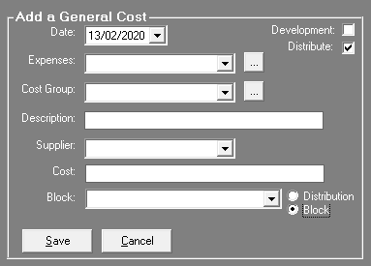

- Date: Select the date of your invoice from the drop-down list.
- Expenses: Select the expense from the drop-down list.
- Cost Group: Select the cost group from the dropdown list.
- Description: Type in any description of your choice (this will reflect on the report)
- Supplier: Type in the supplier’s name, or select the supplier from the drop-down list.
- Cost: Type in the rand value of the invoice, (example 1000)
- Distribute: Next to Block, choose either the Distribution button that allows you to allocate towards a group of blocks/cost centres, or the Block button that allows you to allocate to a specific block.
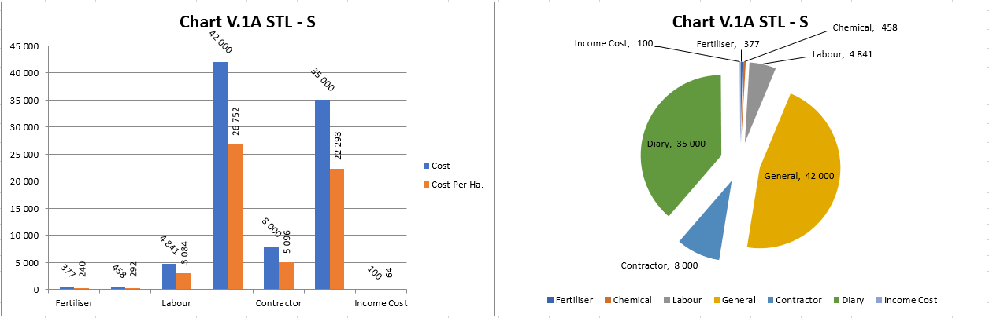
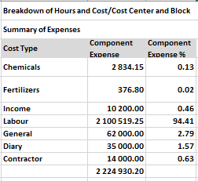
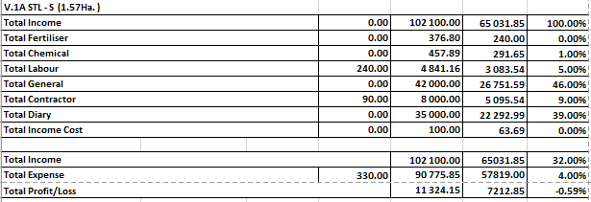

Distribute Salaries

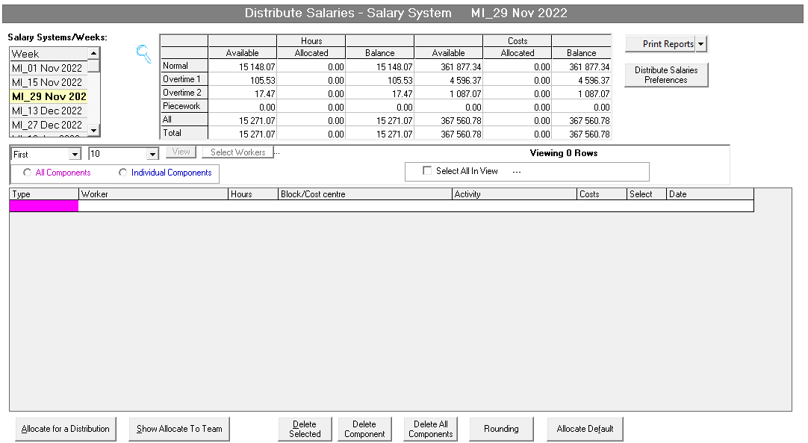

- At the top left, below Salary Systems/Weeks: The period date imported from your payroll program will be displayed. (Double-click on the payroll period that you wish to allocate).
- The table at the top displays your payroll hours and the rand value of each section (Normal, Overtime, and Piecework)
- When all the hours are allocated, the Balance columns should display 0.00 – values.
- The “Print Reports”-button has a few useful reports to print when needed.
- The “Distribute Salary Preferences”-button allows you to choose from two options: All: Which displays all the components and Intelliview: which displays only the components you have in the period.
- This is a filter to be used for allocations. You can select the number of allocations to display, and click on the View button.
- The components screen will be displayed to select which components you want to view. Double-click on the relevant component colour.
- All components & Individual Components: When starting to allocate you must first choose one of these options. All Components enable you to allocate hours where you do not distinguish between Normal time and Overtime etc. Individual Components enable you to allocate according to Normal time and Overtime etc. The colour code must be selected before allocating.

Allocation Screen Columns

- Type: If you have selected ‘Individual Times’, you can double click on this button to change the colour, and allocate the hours for each colour individually.
- Worker: Double-click on the blank line under worker. A screen will appear with a list of workers for this applicable payroll period, including their total hours. Select the worker, or multiple workers, and click on Allocate. “Workers Selected” will be displayed.
- Hours: Type in the hours worked for a specific activity. Remember that the hours entered will be subtracted from each worker selected and will be allocated to that activity.
- Block/Cost centre: Double-click on the blank line. A list of blocks/cost centres will appear. Select the applicable block/cost centre, where the work was completed.
- Activity: Double-click on the blank line. A list of activities will appear. Select the applicable activity, which was completed.
- Costs: After the activity has been selected, the allocation will be completed and the rand value will appear under costs. You can now start with a new allocation line.
- Select: If you wish to delete a line, you can mark the lines to delete in this column.
- Date: The period date will automatically be displayed for each allocation.

- Allocate for a Distribution: Allocate hours of employees to a group of blocks/cost centres. (These groups are set up under the “Cost Distribution” option)
- Show Allocate to Team: First click on the worker column, then you can click on this button to show the custom teams you have set up in the costing module to select.
- Delete Selected: By inserting a tick in the “Select” column, you mark which rows should be deleted. Once the selection is completed, click on Delete Selected.
- Delete Component: Select which component you want to delete, and click this button. All of the allocations done for this component will then be deleted.

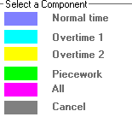

- Delete All Components: All the allocations will be deleted, and you will have to redo the allocations again.
- Rounding: Only to be used when needed to correct any rounding issues.
- Allocate Default: Click on this option to allocate to the default allocations you have set up previously. (Employees that always do the same activity on the same block/cost centre) All the hours will automatically be allocated according to the Default Allocation setup. Do this before you start to allocate hours manually.

Financial Reports

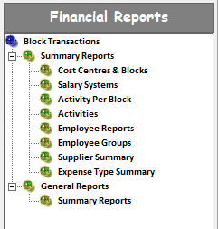

- Cost Centres & Blocks: Multiple options are available. Choose from blocks/cultivars to cost centres and activities. This report imports figures from our other FMA modules.
- Salary System: If you import more than one costing file, from more than one Payroll system, or just one payroll system, it will show you their amounts separately and display towards which block/cost centre it was allocated.
- Activity Per Block: This Excel report has 3 x Excel tabs displaying hours/rand/total, spend on blocks/cost centres.
- Activities: List that reflects all your activities, with the total amount of hours and Costs allocated towards it.
- Employee Reports: Filter per activity, and it will show you all the workers, their hours, and costs allocated towards the selected activity.
- Employee Groups: Filter according to the employee group (as imported from payroll) to see towards which block/cost centres the hours and costs have been allocated.
- Supplier Summary: (only for General Costs users) Displays each supplier and total cost.
- Expense Type Summary: Displays the expenses you have set up, with a total cost.
- Summary Reports: Multiple options are available to choose from. Select your pay period/periods and use the filters to build your report.

