


FARM MANAGEMENT AFRICA FERTILIZER MODULE

STUDY GUIDE

T: +27 21 874 1047
sales@donkerhoekdata.co.za support@donkerhoekdata.co.za
Simondium Guild - R45 - Simondium
www.donkerhoekdata.co.za



Who is Donkerhoek Data?
It all began in 1982 on the farm Donkerhoek, situated in Simondium. Farmer Robert Koch developed and introduced specialized agricultural software to the industry.

Today this innovation still continues, making Donkerhoek Data an industry-acknowledged service provider to more than 1,000 clients. Donkerhoek Data also offers comprehensive hardware services.

The Payroll Africa User Manual
Do consult our extensive user manual. It offers information on using Payroll Africa’s program functions and has search facilities.

This symbol indicates which section in the manual has more information on the particular topic. Updates will be made available on our web page.

Avoid high bank charges with
We advise clients to use Paysoft for electronic payment transfers. You pay a ﬁxed price per transaction with Paysoft. Transaction fees are lower than what the banks charge and there are no monthly or hidden costs.

Paysoft offers tight security and is just as safe as electronic banking. You can also use it to pay your debtors. An appointed staff member will gladly give a demonstration at a time that suits you.

Other Donkerhoek Data Products
Farm Management Africa
Spray, fertilizer, record keeping and reports, pest monitoring, vehicle register, GlobalG.A.P., Nature’s Choice, IPW, IPM points.

Income Module
Speciﬁc income per block can be allocated.

Payroll Africa
User-friendly Payroll (Wages and Salaries) for the farm, cellar, or business. Additional hardware that handles time and attendance, as well as piecework, can be incorporated.

FARM MANAGEMENT AFRICA FERTILIZER MODULE
STUDY GUIDE
Fertilizer Module

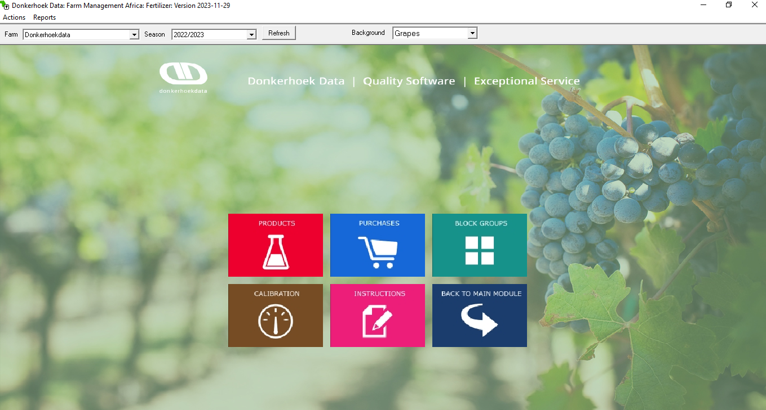

- Main Screen

- Actions – Fertilizer Module Icons Duplicate.
- Reports.
- Farm – Your farm name/Current farm logged into.
- Season – Current season.
- Refresh – Click on this button whenever you want to return to the main. fertilizer module screen.
- Dropdown (Grapes/Apples etc.) – Background Wallpaper.

- Products

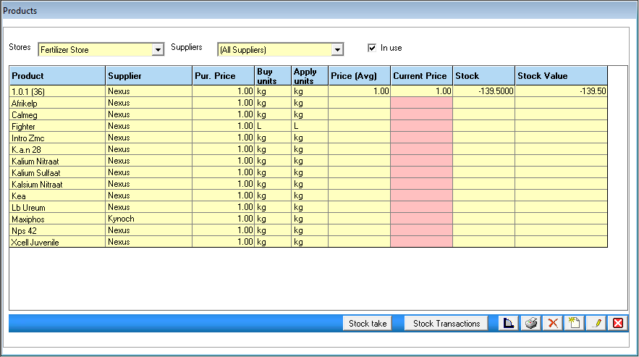

- Stores – Select the correct store.
- Suppliers – Select the correct supplier.
- Untick this option to view all inactive products.
- Stock Take - doing a stock take for all your fertilizer products.
- Stock Transactions - shows you all transactions for the fertilizer product you have selected. You can also edit price averages for purchases made in the history for this product.
- Purchases - shortcut to your purchases of fertilizer products.
- Print Product Report – prints the information as seen on the screen under Fertilizer Products.
- Basic icons - add new, delete, edit, and close.

- Product Setup

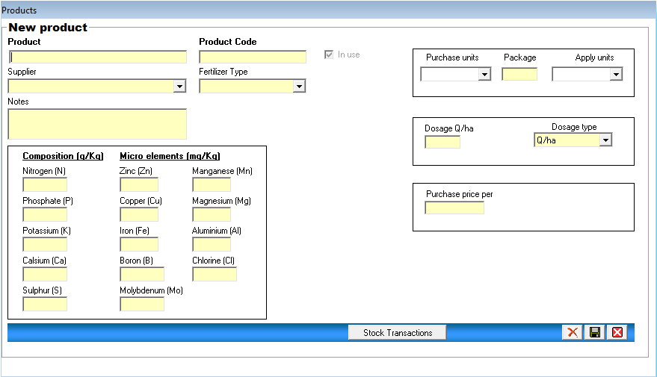

- Product - Insert your product name.
- Product Code – insert the code for the fertilizer product if you have one (not compulsory).
- Supplier - select the supplier from whom you are buying this product.
- Fertilizer Type, select organic or inorganic.
- Notes - type in anything you want to remember, for this product.
- Composition (g/kg) – fill in the relevant information.
- Microelements (mg/Kg) – fill in the relevant information.
- Purchase units - Select the units you buy this product in.
- Package - type in the size of the fertilizer product.
- Apply units - select the unit you use this product in.
- Dosage type - select from the dropdown list how this product will be applied.
- Dosage - type in the dosage for the fertilizer product according to the dosage type.
- Purchase price per - type in the price per purchase unit.
- Stock Transactions – if you click on this button, you will be able to view the transactions linked to this product, and you can edit the average price.
- Clicking on this button will enable you to copy this product to another fertilizer store.
- Stock Take
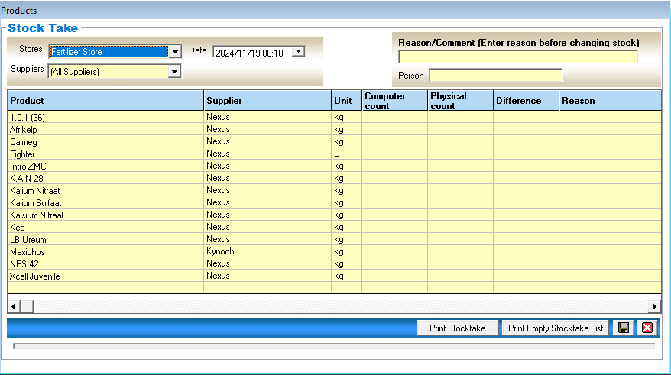

- Stores/Suppliers - automatically selected.
- Date - select the correct date when the stock take was done.
- Reason/Comment - type in the reason for the stock take.
- Person - type in the name of the person taking the stock.
- Computer count - shows the stock value that the program has accumulated.
- Physical count - enter each product’s current stock take value in this column.
- Print stocktake - print the stocktake values you have captured.
- Print Empty stocktake list form prints an empty stock list form for you to print out and fill in when taking your actual stock in the store.
- Save button - saves the stock take values and adds your actual count of each product to your fertilizer products.
- Purchases

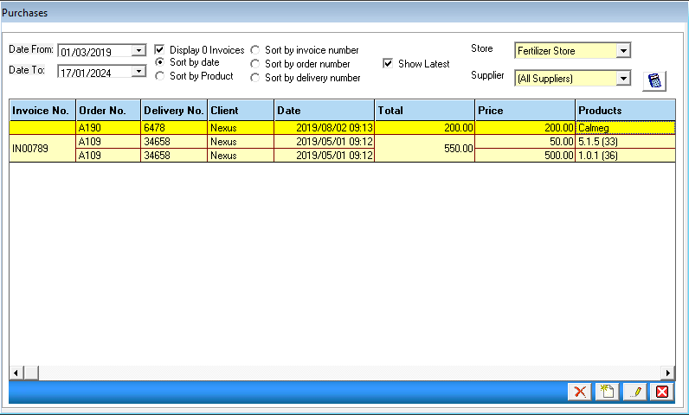

- Date from/to - select date range to view purchases.
- Display/Sort buttons - filter how you want to view your purchases.
- Store - select the store to view the specific store's purchases.
- Supplier - select suppliers to view their purchases.
- Click on the Apply filter button to apply your selection.
- Add a new button - to add a new purchase.
- Delete button, select the invoice you want to delete and click the delete button.

- New Purchase
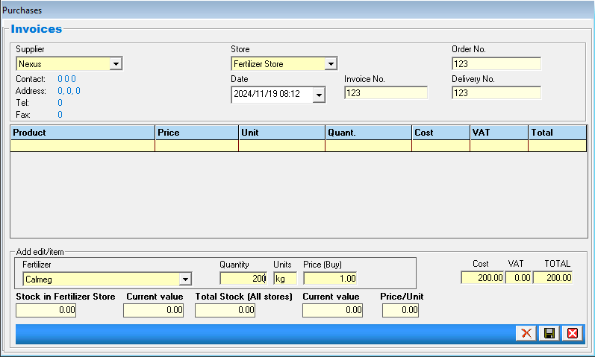

- Supplier - select the supplier for this purchase.
- Date - select the date of the purchase.
- Store - select the store.
- Order No - type in the order number (not compulsory).
- Delivery No - type in a delivery number.
- Invoice No - type in your invoice number. This number can be added when you get the invoice, by editing the purchase.
- Click on the add product button at the bottom, to add the products you have purchased.
- Fertilizer - select the fertilizer purchased from the dropdown list.
- Quantity - type in the amount of the fertilizer purchased.
- Units – shows the units of the product selected.
- Price (Buy) – edit, if the price per purchase unit has changed.
- Cost – shows the total cost of the invoice before VAT.
- VAT can be added.
- Total - shows the total price value of the quantities purchased for the product.
- Click on save to add the product to the purchase.
- Save purchase

- Calibrations
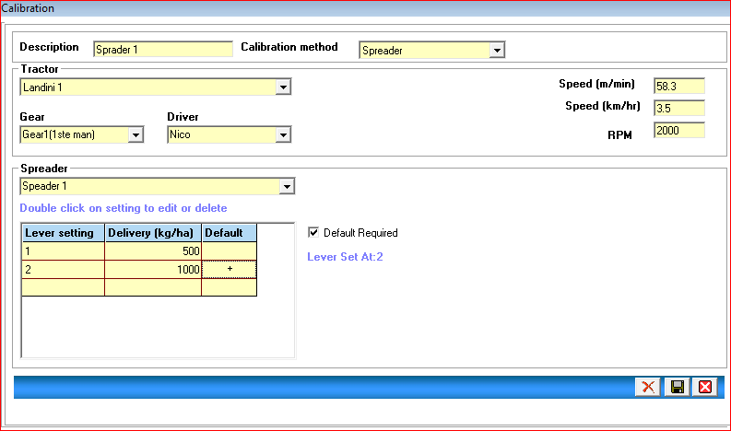

- When adding a new calibration, the above screen will appear.
- Description - type in the name of the calibration.
- Calibration method – automatically selected.
- Tractor - select the tractor for this calibration.
- Gear - select the correct gear.
- Driver – automatically selected.
- Spreader - select the spreader for this calibration.
- Delivery: kg/ha – set default lever setting by putting in a + sign.
- Save the calibration.

- Block Groups
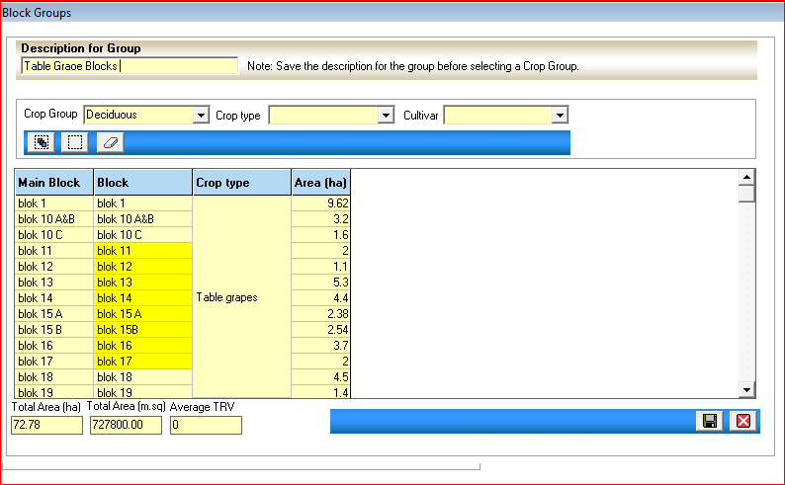

- Description for Group - type in the name of the block group.
- Crop Group / Crop Type and Cultivar - select these options to generate your list of blocks.
- Click on the desired blocks for this group (they will appear in yellow).
- Save the group.

- Instructions
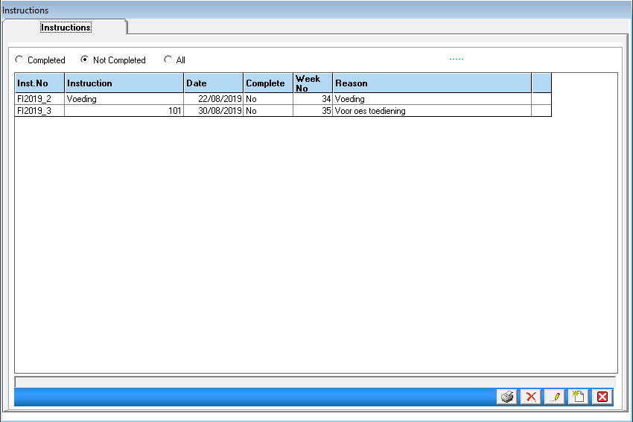

- When opening the instructions icon, the above screen will appear.
- Completed/Not completed and All - different filter options to view the instructions.
- Click on the delete button to delete an open or closed instruction. Closed instructions stock will be transferred back to the chemical store.
- Click on add new instruction to create a new instruction.
- Print Instruction Report – Select the instruction and click on the print button to print the instruction.

- New Instruction

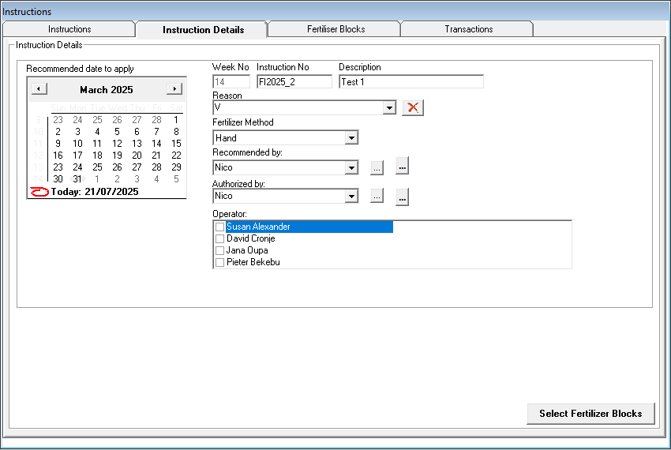

- Instruction details tab.
- Select date - week number will be filled in automatically.
- Instruction No. – Filled in automatically.
- Description - type in the description for the instruction.
- Reason - select the reason from the dropdown list, or add a new reason simply by typing in the new reason. Delete option available.
- Fertilizer Method – Select the method, and how the fertilizer will be applied. When selecting Hand or Irrigation, the calibration frame will not be visible.
- Recommended by and authorised by - type in the names and they will remain there for you to select each time from the dropdown list. The buttons next to the drop-down allow you to delete or edit names, and the other button for add signatures for the respective persons.
- Operator – Select the correct operator/operators for this instruction.
- Calibration - select the calibration to be used in this instruction.
- Click on the Select Fertilizer Blocks button at the bottom. The next screen will appear - Fertilizer blocks.

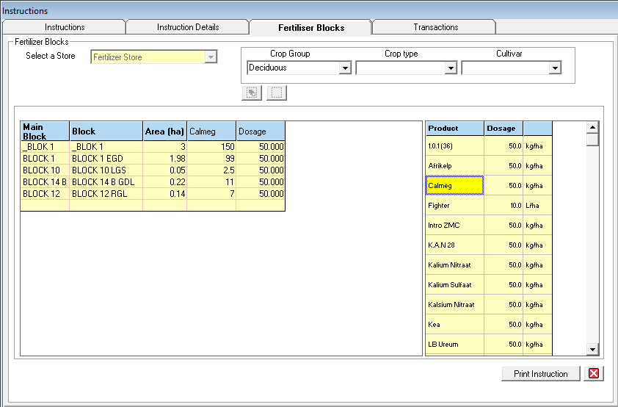

- Fertilizer blocks tab.
- Select Crop Group to show the fertilizer blocks.
- Select all/Deselect all - click on these options to select, or deselect blocks in the list.
- Select a Store – This option will be available to edit if there is more than one fertilizer store for the same farm.
- Select a Group – Select the block group from the dropdown list.
- Blocks – Select the blocks applicable to this instruction. (The blocks will appear in yellow after you have selected them)
- Product – select the fertilizers applicable to this instruction (they will appear in yellow after selection.)
- Dosage (Right) – the dosage of the product can be edited. The dosage will then pull through to all the blocks selected.
- Dosage (Left) – the dosage per block can be edited.
- Print – two options available, with and without calibration.
- Instruction will automatically be saved at this stage.
- You can close the instruction or click on Transaction to complete the instruction.

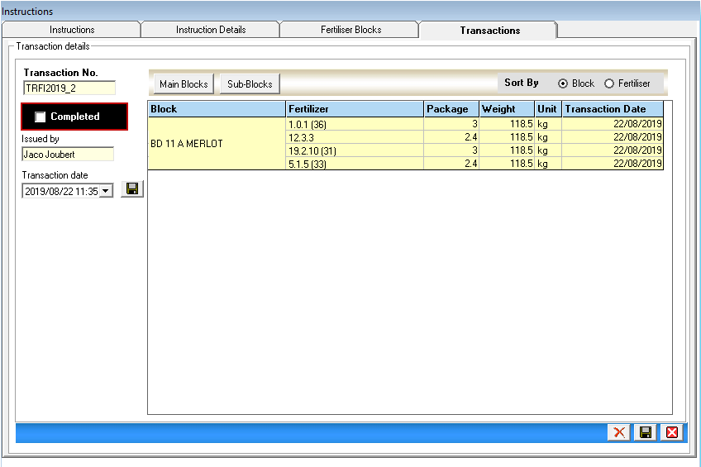

- Transaction tab.
- Once you click on the transaction tab, you will get a message to ask you if you are sure you want to complete the instruction. If you are, click on yes.
- Transaction date – date of the transaction being completed. If you want to change the transaction date of the fertilizer instruction, go to the first tab – Instruction Details and select the new date on the calendar.
- The completed tick must be put in.
- A list of blocks for the instruction will be shown. Here, you can either change the number of packages applied per block or the weight per block applied.
- Once you are satisfied that everything is in order, you can click on save at the bottom.
- The instruction will then be completed, and the stock used in the instruction will be subtracted from your store stock.

- Reports

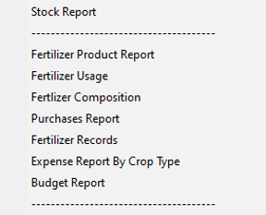

- Stock Report - shows the history of transactions for each fertilizer product, and how the program gets to the current stock values in your store.
- Fertilizer Product Report - shows all your fertilizers and their details.
- Fertilizer Usage - shows a summary of transactions for some time per product.
- Fertilizer Composition – shows each fertilizer's composition.
- Purchases Report - shows your purchases.
- FERTILIZER RECORDS - shows what has been applied on a specific block for some time. Multiple Reports are available.
- Expense Report by Crop Type - shows per crop type and per block the costs involved for fertilizing.

