


FARM MANAGEMENT AFRICA INCOME MODULE

STUDY GUIDE

T: +27 21 874 1047
sales@donkerhoekdata.co.za support@donkerhoekdata.co.za
Simondium Guild - R45 - Simondium
www.donkerhoekdata.co.za



Who is Donkerhoek Data?
It all began in 1982 on the farm Donkerhoek, situated in Simondium. Farmer Robert Koch developed and introduced specialized agricultural software to the industry.

Today this innovation still continues, making Donkerhoek Data an industry-acknowledged service provider to more than 1,000 clients. Donkerhoek Data also offers comprehensive hardware services.

The Payroll Africa User Manual
Do consult our extensive user manual. It offers information on using Payroll Africa’s program functions and has search facilities.

This symbol indicates which section in the manual has more information on the particular topic. Updates will be made available on our web page.

Avoid high bank charges with
We advise clients to use Paysoft for electronic payment transfers. You pay a ﬁxed price per transaction with Paysoft. Transaction fees are lower than what the banks charge and there are no monthly or hidden costs.

Paysoft offers tight security and is just as safe as electronic banking. You can also use it to pay your debtors. An appointed staff member will gladly give a demonstration at a time that suits you.

Other Donkerhoek Data Products
Farm Management Africa
Spray, fertilizer, record keeping and reports, pest monitoring, vehicle register, GlobalG.A.P., Nature’s Choice, IPW, IPM points.

Income Module
Speciﬁc income per block can be allocated.

Payroll Africa
User-friendly Payroll (Wages and Salaries) for the farm, cellar, or business. Additional hardware that handles time and attendance, as well as piecework, can be incorporated.

FARM MANAGEMENT AFRICA INCOME MODULE
STUDY GUIDE

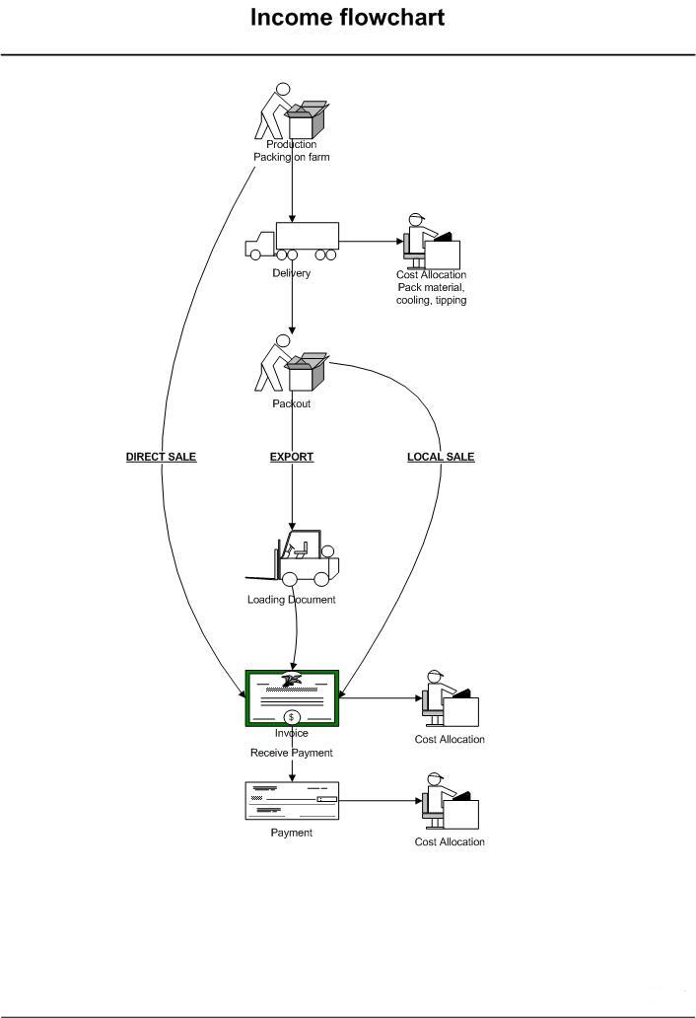

INCOME MODULE SETUP

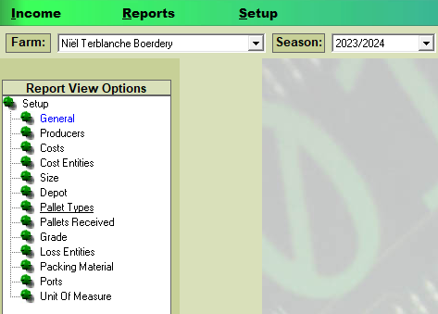

- Producer – (the producer should be set up first) The producer is the farm’s name that provides the fruit and vegetables. Type in any code (Letter or number or combination). Description, type in the name of the producer. Email optional and then select your farm from the drop-down list.
- Costs – These are general costs you as a producer can ask from the people you sell your fruit to, for example, Traveling Expenses/Cooling/Labor, etc. (Costs are optional)

- Cost Entities – Companies/Places or People you sell fruit and vegetables to. (Different Types) NB: cost entities can be set up from the shortcuts when doing a production actual and invoice etc.
  - Agent – Setup for Local sale or Export sale.
  - Direct sale – Set up a client to whom you sell the fruit as it comes from the orchard. (unpacked)
  - Export – Setup export agent or company.
  - Market – Setup Market name for Local Sales.
  - Packhouse – Setup your farm’s packhouse name.
  - Transport – Setup any transport company name or your own farm’s name.

- Size – Set up different sizes for fruit. These sizes will be used when packing the fruit. Add any code, add a description of the size, and under the size type the size of the fruit. Quantity, type in the quantity of the fruit in this size. Net weight, type in the net weight of the fruit.
- Depot – Use this section to set up depots. These depots will be used to store pallets/crates. You will be able to keep stock of how many pallets/crates should be in each depot. (optional)
- Pallet types – Enter a description for the pallet. Enter the length of the pallet in centimeters. Enter the width of the pallet in centimeters. Opening Balance, Enter the amount of these pallets you currently have available. This will be used when keeping stock of pallets. (optional)
- Pallets received – Each time you receive pallets at a depot, you should enter them here. This will help with your pallet stock control. (optional)
- Grading – Use this section to set up grades for your fruit.
- Lost entities – You can assign losses to Loss Entities. This allows you to keep track of stock and the reasons for losses. (optional)
- Packing Material – Use this section to set up your different packages. You should create one for each size, type, and fruit. Cost unit – Enter the cost of the packing material per unit in Rand. Net weight – Enter the weight in Kilogram of the packing material with the fruit in it. Select from the list which fruit will be packed in this specific packing material.
- Ports – Add all ports you deliver from and to. (optional)
- Unit of measure – This is the units you set up how the fruit will be delivered from the land to the packhouse or sold as a direct sale. For example, delivered in “Bins/Crates/KG” etc. (when you set up KG, the empty weight should be 1 kg and the filled weight should be 2 kg, the Netto weight will then be calculated as 1 kg.
- General – Complete the company details at the bottom. These details will be printed on invoices. All other fields should stay as is. Company Logo Location, you can add your company’s logo here and it will print on the invoices with the company details you filled in.

INCOME
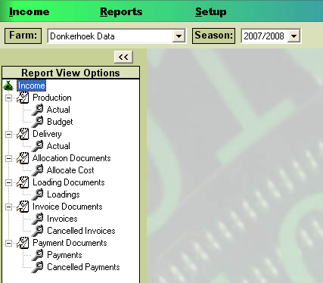

- Production – Use this section to control crops arriving at your store from the farm blocks. There are two options: Budget: The number of crops you predict you will receive. (This option does not have to be used) Actual: The number of crops you receive.
Production Actual
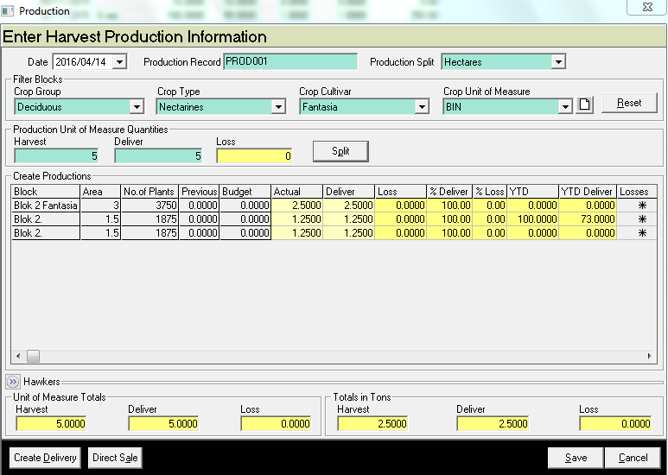
- Date Choose the date from the drop-down calendar.
- Production Record Each production record number should be unique.
- Production Split You can choose to automatically split the production between the selected blocks. If you would like to use this option, choose whether you would like it split evenly between all selected blocks, by hectare or by plant. If you do not use this option, you may enter the amounts manually.
- Add to Amount If you need to edit a production record, you can add to the amount. For example, if the original amount was 400 and you receive an additional 100 you can click on the block and type ‘100’ and enter. The amount will change to 500. This means that you can create one production per cultivar and simply add amounts each time you receive produce at your store.
- Edit Amounts: This option allows you to edit amounts previously entered. This means that the figure previously entered will be overwritten.
- Crop Group, Crop Type, Crop Cultivar Use these filters to view the correct block in the table below.
- Crop Unit of Measurement This is the measurement of each unit (bin/crate) delivered to the store.
- Production Unit of Measure Quantities Enter this amount as per your unit of measurement. For example, the number of bins/crates you receive. Enter the amount harvested from the blocks and the amount received at the store. The Loss will be calculated automatically.
- Use this button to split the amount delivered to the blocks in the table according to the method specified at Production Split.
- Block, Area & No. Of Plants The information in these columns will be completed automatically according to filters selected using the information set up at Main Module > Setup Spray Blocks
- Previous This is the amount that has been delivered from this block previously.
- Actual Enter the amount that was harvested from this block.
- Deliver Enter the amount that was delivered to the store.
- Loss Any differences between the actual and delivered amounts will be calculated by the program. If there are any losses, you can click on * at the end of the row to allocate losses (see Main Module > Income Module > Income > Allocate Documents for more information). %Deliver and %Loss will show the percentage delivered and lost according to the actual amount harvested.
- YTD This column shows the year-to-date amount that has been harvested.
- YTD Deliver This column shows the year-to-date amount that has been delivered to the store.
- Hawkers Click on and the following screen will appear:

Hawkers Screen

This section allows you to sell losses directly to hawkers.

- Total Qty Sold to Hawkers This will show the total amount of units that have been sold to Hawkers previously.
- Total Qty Available to Hawkers This will show the number of unsold losses for this production. You will not be able to sell more than this amount.
- Amount Sold This will show the amount that has been sold previously.
- Qty Sold to Hawkers Enter the amount you would like to sell to Hawkers.
- Amount Paid by Hawkers Enter the amount of money the hawkers paid for this amount.
- Unit of Measure Totals This section shows the amount harvested, delivered, and lost in units specified at Crop. Unit of Measure.
- Totals in Tons This section shows the amount harvested, delivered, and lost in tons.
- This is a shortcut to Deliver the fruit to the packhouse.
- Use this function to sell the bins/crates as is and create an Invoice for the client.

Invoices
Use this section to create invoices.
Direct Sale Use this option when you would like to sell produce that has not been packed but sold as is in the bin/crate or Kg.

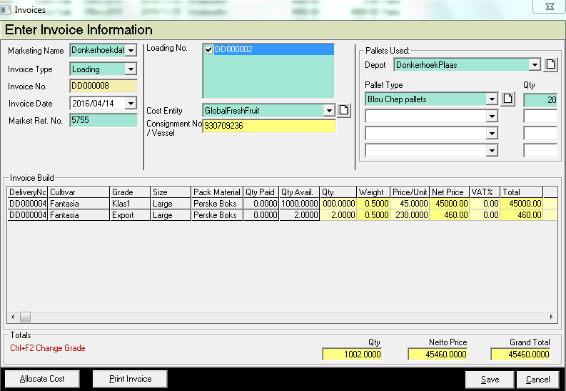

- Marketing Name Type in the correct marketing name.
- Invoice Type Select the invoice type from the drop-down list.
- Invoice No. Auto-generated, this field will be completed automatically.
- Invoice Date Select the correct date for the invoice.
- Market Ref No. Enter the reference number used by the market or any reference number.
- Production No., Loading Documents, or Delivery Documents This heading will change according to the invoice type selected. Select what productions/loading/deliveries you would like to use for this transaction. More than one may be selected.
- Cost Entity Select the correct cost entity from the drop-down list. These are the cost entities set up at Main Module > Income Module > Setup > Cost Entities. Click on to add more cost entities.
- Pallets used If pallets were used with this sale then you can complete this section to help control pallet stock.
- Depot Select the correct depot from the drop-down list. These are the cost entities set up at Main Module > Income Module > Setup > Depot. Click on to add more depots.
- Pallet Type Select the correct pallets from the drop-down list. These are the pallets set up at Main Module > Income Module > Setup > Pallets. Click on to add more cost pallets. Up to three different types of pallets can be used for one invoice
- Qty Enter the number of pallets used.
- Production This column indicates what production you are working with.
- Cultivar This column indicates what cultivar you are working with.
- Grade Press CTRL and F2 on your keyboard to change the grade. Select the correct option for the drop-down list. If the grade you require is not available, you may create it at Main Module > Income Module > Setup > Grade.
- UOM This column shows the Unit of Measurement used in this production.
- Qty Paid This column indicates the number of units that have been paid for.
- Qty Available This column indicates the amount if units that are available to sell.
- Qty Enter the number of units you would like to add to this invoice.
- Weight This field will be completed automatically according to the UOM and Qty.
- Price/Unit Enter the price per unit. If the price has not been finalized, you may leave this field empty and enter the price when putting the payment through.
- Net Price This field will complete automatically according to the price/unit and Qty.
- VAT % Enter the percentage of VAT you would like to charge.
- Total This column indicates the total amount
- Totals Qty This field indicates the total amount of units for the entire invoice.
- Netto Price This field indicates the total Net Amount for the entire invoice.
- Grand Total This field indicates the total payable amount for the entire invoice.

- Use this function as a shortcut to Main Module > Income Module > Income > Allocation Documents > Allocate Costs.

- Use this option to print the invoice.

- If you are unsure what the price will be for this product, you may enter it when receive the payment at Main Module > Income Module > Income > Payment Documents > Payments. First, select Part Invoice and enter the price. The price on the invoice will automatically update. The same applies to the QTY (quantity).
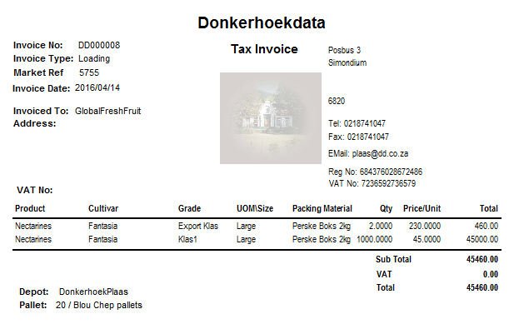

Allocate Costs

Use this function to allocate costs from deliveries, invoices, and payments.

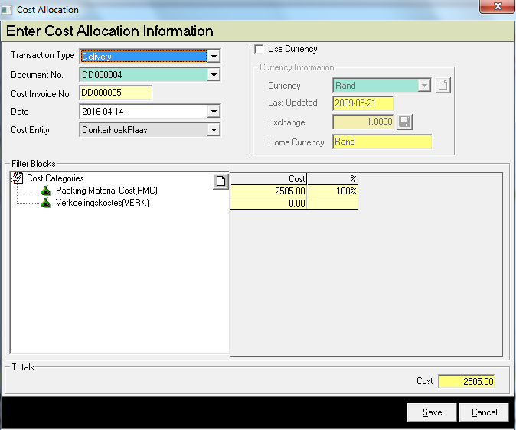

The top section on the Allocate Costs screen can be kept as is, continue to start at cost categories.

- Cost Categories Select the categories you would like to assign this cost to. If the category you require is not available, click on to add it.
- Cost Each category will have its own cost field. Enter the amount of money you would like to assign to each category.
- % This column indicates the percentage that has been assigned to the category.
- Cost This field indicates the total cost.

Payments
Use this section to control payments received for invoices.

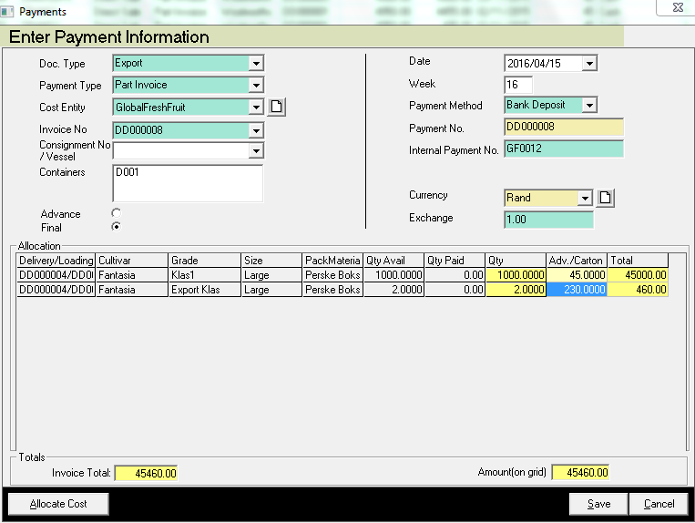
- Doc. Type Select the type of invoice you would like to create a payment for.
- Payment Type Usually debtors do not pay the full amount of the invoice at the first payment. There are two different Payment Types:

- Part Invoice Use this option if you would like to split the payment by the invoice amount. For example, if the debtor would like to pay R5 per unit as an advance, you can simply enter R5 in the Adv/Carton column.
- Part Quantity Use this option if you would like to split the payment by quantity. For example, if the debtor would like to pay for 6 of 20 units, you can enter a 6 in Qty Column.

- Cost Entity Select the correct cost entity from the drop-down list. Click on to add more cost entities.
- Invoice No Choose the correct invoice from the drop-down list. Only invoices for the type selected at Doc. The type will be available.
- Date Select the date for this payment.
- Week This field will indicate the week number according to the date you have selected.
- Payment Method Select the correct payment method from the drop-down list.
- Payment no Enter a payment number.
- Internal Payment No This field allows you to enter an additional reference number for this payment, for example, a cheque or cash receipt number.
- Select the currency from the drop-down list.
- Exchange Enter the exchange rate for this. The exchange rate should be entered according to your home currency.
- Advance Select this option if it is a part payment.
- Final Select this option if this is the final payment for this invoice.
- Delivery no., Cultivar, Grade, Size These columns will be completed automatically using information from the selected invoice.
- Qty Avail. This field indicates the number of units that have not been paid for.
- Qty Paid This field indicates the number of units paid for.
- Qty Enter the number of units you would like to put payment through for. This field is only editable if Part Quantity is selected at Payment Type.
- Adv. /Carton Enter the price per unit.
- Total This column indicates the total amount payable.
- Invoice Total This field indicates the total amount specified on the selected invoice.
- Amount(on the grid) This field indicates the total amount for this payment. Often market prices change so the invoice total and the amount paid can differ. For this reason, this field does not need to match the invoice total.

- Use this function to allocate costs.

Delivery

When doing a Production Actual, you have the option for Direct Sale which will bring you to the Invoice section, the other option is Delivery which will bring you to the below section as seen in the print screen. You will use this section to receive and package fruit/vegetables at your pack store.

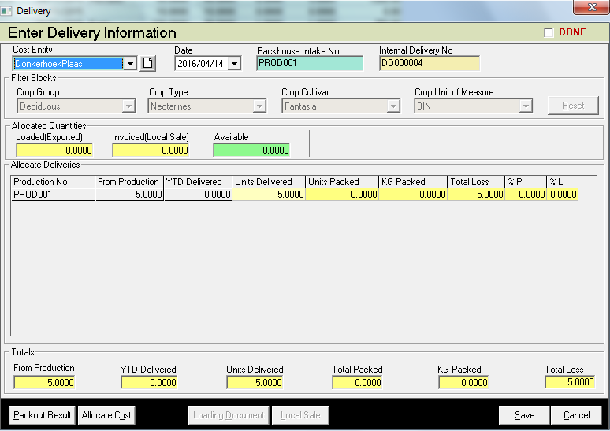

- Cost Entity Select the correct cost entity from the drop-down list.
- Date Select the correct date for the delivery.
- Packhouse Intake No Enter a pack house intake number for this delivery. This can consist of both letters and numbers. We recommend using the block and cultivar names to make them easier to recognize.
- Internal Delivery No Complete automatically.
- Add to units delivered If you need to edit a delivery record, you can add to the amount. For example, if the original amount was 400 and you deliver an additional 100 you can click on the block and type ‘100’ and enter. The amount will change to 500. This means that you can create one delivery per cultivar and simply add amounts each time a delivery is made.
- Edit units delivered This option allows you to edit amounts previously entered. This means that the figure previously entered will be overwritten.
- Crop Group, Crop Type, Crop Cultivar Use these filters to view the correct block in the table below.
- Crop Unit of Measurement This is the measurement of each unit (bin/crate) delivered to the store.
- Use this button to reset filters.
- Allocated quantities Loaded(Exported) and Invoiced(Local Sale) will be completed automatically according to transactions at Main Module > Income Module > Income > Loading/Invoice Documents. Available will indicate how many units from this delivery are still available.
- Production Number This column indicates the production number for the production used for this delivery.
- From Production This column indicates the number of units in production.
- YTD Delivered This column indicates the amount that has been delivered this year.
- Units Delivered Enter the number of units delivered to the pack house. First, complete this field before entering the units packed.
- Units Packed This column indicates the number of units already packed.
- KG Packed This column indicates the number of kilograms already packed.

- Total Loss This column indicates the number of units lost. This will be the difference between the amounts delivered and packed.
- %P This is the percentage amount packed.
- %L This is the percentage amount lost.
- Totals These are the total amounts for the entire delivery.

- Use this option to pack the produce. If you click on this button, the following screen will appear:

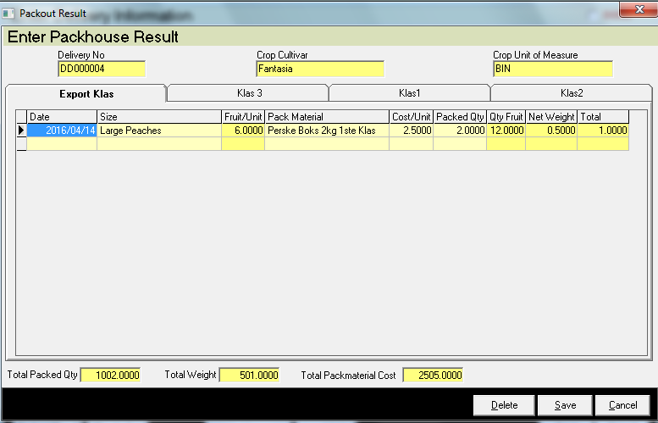

- Delivery No., Crop Cultivar, and Crop Unit of Measure These fields will be completed automatically using information from the delivery.
- Export, Klas 3, Klas 1 Use these tabs to insert packaged produce for each type applicable.
- Date Select the date the produce was packed.
- Size Select the correct size from the drop-down list.
- Fruit/Unit The amount of fruit per unit will be calculated automatically.
- Pack Material Select the correct pack material from the drop-down list.
- Cost/Unit This field indicates the cost of each packaging unit and will be completed automatically. You may edit this field.
- Packed Qty Enter the number of packaged units that were produced.
- Qty Fruit This field will indicate the amount of fruit in this package and will be completed automatically.
- Net Weight This field will indicate the net weight of the package and will be completed automatically.
- Total This field will indicate the total.
- Total Packed Qty, Total Weight, and Total Pack Material Cost These fields show the total amounts for this delivery.

- Once you have created your pack out, click on save. You will be asked to allocate packing material costs. Allocate and click on Save.

- Use this function if you want to add any additional costs to the delivery.

- Use this function if you are exporting the packaged fruit with a ship to another country. If sold locally then click on Local Sale.

- Use this function if you are selling the packaged fruit to a local market within South Africa. Clicking on Local Sale button will take you to the Invoice screen.

Loading Document

Loading documents are created for export sales.

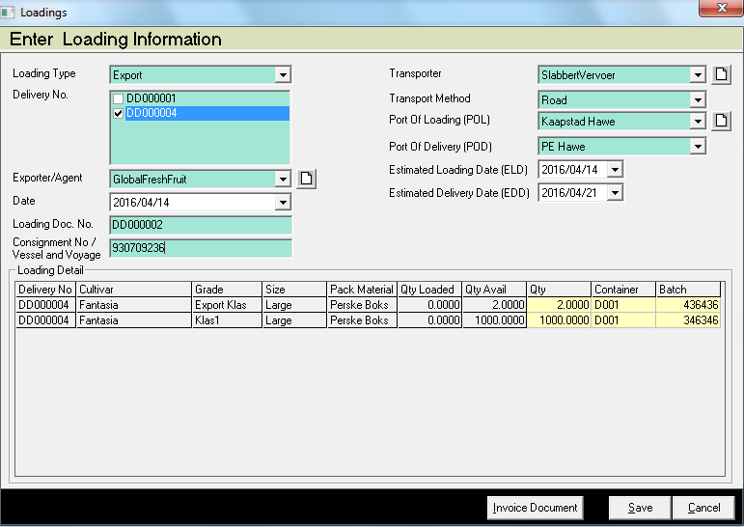

- Loading Type Select the loading type from the drop-down list.
- Delivery No Choose what deliveries you would like to use for this load. You may select more than one delivery.
- Exporter/Agent Select the exporter or agent from the drop-down list. If the exporter or agent you require is not available, click on to add a new exporter or agent.
- Date Select the date from the drop-down calendar.
- Loading Doc. No, this number will be generated automatically.
- Consignment No/Vessel and Voyage Enter a Consignment or Vessel and Voyage number.
- Transporter Select a transporter from the drop-down list, the cost for the transportation will be allocated to this transporter. Click on to add new cost entities.
- Transport Method Select the transport method from the drop-down list.
- Port Of Loading (POL) Select the port where the goods will be loaded from the drop-down list. Click on to add new ports.
- Port of Delivery (POD) Select the port where the goods will be delivered from the drop-down list. Click on to add new ports.
- Estimated Loading Date (ELD) Select the date you expect the goods to be loaded.
- Estimated Delivery Date (EDD) Select the date you expect the goods to be delivered.
- Deliver no, Cultivar, Grade, Size, Pack Material. These columns will show details for the selected deliveries.
- Qty Loaded This column indicates the amount that has already been loaded.
- Qty Avail This column indicates the amount available.
- Quantity Enter the amount that should be added to this loading document.
- Container Enter a container number.
- Batch no. Enter a batch number.

- Use this function to go to the Invoices screen.

Reports

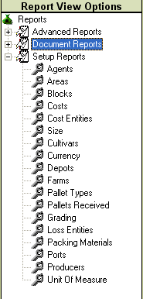

- Set up Reports, print all your setups that you have done.
- Document Reports, print all the transactions you have done in their different sections.
- Advanced Reports prints more detailed reports.

