

FARM MANAGEMENT AFRICA INSTALLATION

STUDY GUIDE

T: +27 21 874 1047



 [sales@donkerhoekdata.co.za](mailto:sales@donkerhoekdata.co.za)  [support@donkerhoekdata.co.za](mailto:support@donkerhoekdata.co.za)



 Simondium Guild - R45 - Simondium

[www.donkerhoekdata.co.za](http://www.donkerhoekdata.co.za/)





# Who is Donkerhoek Data?

It all began in 1982 on the farm Donkerhoek, situated in Simondium. Farmer Robert Koch developed and introduced specialized agricultural software to the industry.

Today this innovation still continues, making Donkerhoek Data an industry-acknowledged service provider to more than 1,000 clients. Donkerhoek Data also offers comprehensive hardware services.

# The Payroll Africa User Manual

Do consult our extensive user manual. It offers information on using Payroll Africa’s program functions and has search facilities.

This symbol indicates which section in the manual has more information on the particular topic. Updates will be made available on our web page.

# Avoid high bank charges with

We advise clients to use Paysoft for electronic payment transfers. You pay a ﬁxed price per transaction with Paysoft. Transaction fees are lower than what the banks charge and there are no monthly or hidden costs.

Paysoft offers tight security and is just as safe as electronic banking. You can also use it to pay your debtors. An appointed staff member will gladly give a demonstration at a time that suits you.

# Other Donkerhoek Data Products

Farm Management Africa

Spray, fertilizer, record keeping and reports, pest monitoring, vehicle register, GlobalG.A.P., Nature’s Choice, IPW, IPM points.

Income Module

Speciﬁc income per block can be allocated.

Payroll Africa

User-friendly Payroll (Wages and Salaries) for the farm, cellar, or business. Additional hardware that handles time and attendance, as well as piecework, can be incorporated.

FARM MANAGEMENT AFRICA INSTALLATION

STUDY GUIDE

**Farm Management Installation**

**Installation Manual Process**

1. Create C:\Africa
2. Create C:\Africa\Fma
3. Create C:\Africa\Setup
4. Copy the DF1 folder from your flash drive or PC and paste it under the setup folder.
5. Copy all files and folders (except Setup, Stick CD, and Stick CD Jet Flash folder) and paste into the FMA folder.
6. Run the Setup.exe under C:\Africa\Setup \DF1\Setup\3_Pre-Install
7. Run the Setup.exe under C:\Africa\Setup \DF1\Setup\4_FMA_Setup
8. If the client uses costing, run setup under C:\Africa\Setup \DF1\Setup\5_Costing_Reports
9. If the clients use income, run setup under C:\Africa\Setup\DF1\Setup\6_Income_Setup
10. If the clients use income, run setup under C:\Africa\Setup\DF1\Setup\7_Income_Updater_Setup
11. Install 7.zip

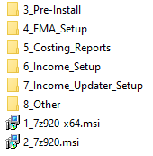

**To create the icon:**

1. Right-click on C:\Africa\FMA\DF1.exe – Send to desktop – You can rename the icon.
2. Desktop: Right-click on the shortcut – Properties – the Target & Start in should be like below:

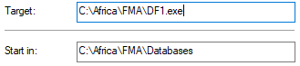

1. Next, go to the **C:\Africa\FMA\Databases** folder open the license exe, and complete the license.

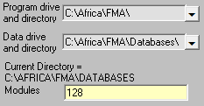

1. Program Drive and directory: C:\Africa\FMA\
2. Data Drive and directory: C:\Africa\FMA\Databases

**Modules:**

1 - Main Module + Spray Module + Fertilizer Module and all the smaller Modules.

12 – All of the above + Costing Module

128 – Includes all the Modules

**FMA Installer Process**

1. Download the FMA Installer.exe from https://downloads.donkerhoekdata.co.za/fma/
2. Run the FMA Installer.exe
3. Click on the “Run” option
4. The following screen appears:

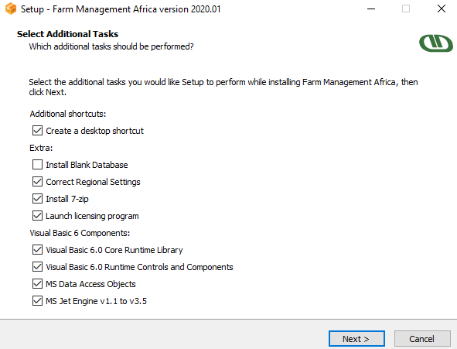

1. This screen indicates all items to be installed and created by the FMA Installer.exe
2. Install Blank Databases will not be selected, you can choose if new clean data should be installed in the program or not.
3. Click on Next
4. Click on Install
5. The installation process will begin.
6. You will notice that the program icon will appear on your desktop.
7. Next the license screen will come up for you to fill in all the company details.
8. Once the license is completed the last screen of the installer will come up and you will have to click on Finish.
9. The Farm Management Program will be installed and you can open the program and start working.

**Additional Information**

* The following items will be automatically created when you run the FMA Installer.exe
* The program icon and paths
* All folders under the C drive for the program to work correctly.
* Regional settings will be adjusted
* 7 zip will be installed
* All program setups will be installed/run
* FM20.dll file will be registered

**How to install and use FMA on a network drive:**

**PART I: THE SERVER-PC**

1. Install all the FMA prerequisites and application files to the default local directory, following the same procedure as with a stand-alone installation.
2. Right-click the Africa folder (containing the FMA application folder) and select Properties
   1. In the General tab, remove the Read Only checkbox

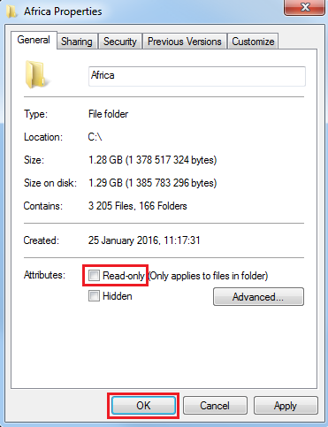

* 1. In the Sharing tab, choose Advanced Sharing
     1. Check the “Share this folder” checkbox
     2. Modify the Permissions so that “Everyone” has “Full Control”
     3. 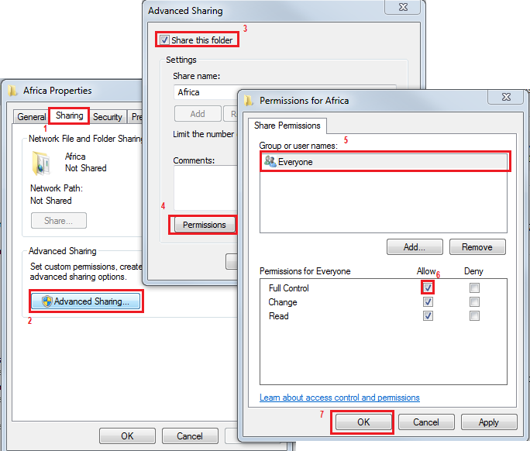
  2. In the Security tab, click Edit
     1. Then click Add
     2. Type “everyone” and then “Check Names” – “everyone” will become underlined –then click OK
     3. Set the permissions for Everyone to **ALLOW: FULL CONTROL** and click OK

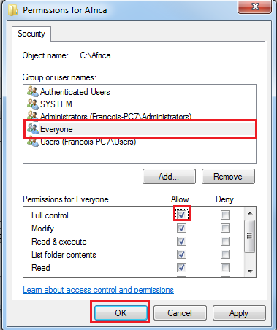

* + 1. Click OK once more to close the open dialogs.

1. To verify access to the Africa folder on the SERVER-PC, open File Explorer / This PC
   1. In the Address Bar, type “\\localhost\” and press enter
   2. The Africa folder should now be visible and browsable.
   3. Close the window. Do not map anything here.
2. The FMA icon and license setup is as follows:

|  |  |  |
| --- | --- | --- |
| **SERVER-PC** | **PROGRAM PATH** | **DATA PATH** |
| **ICON** | C | C |
| **LICENSE** | C | C |

1. Finally, find the Computer Name of the SERVER-PC:
   1. Right-click on This PC / Computer / My Computer and search for Computer Name – you will need this when mapping network drives in Part II of this guide.
   2. You can also use the direct IP Address of the SERVER-PC:

Using the CMD prompt, run the command “ipconfig” and press enter. Look for the IPV4 Address of the Ethernet (or WIFI adapter) and write this down.

**PART II: THE CLIENT-PC**

1. Install all the FMA prerequisites and application files to the default local directory, following the same procedure as with a stand-alone installation. Do not bother too much with the local “databases” folder, only the license information will be stored here.
2. Map the Africa folder that was shared on the SERVER-PC:
   1. Open File Explorer / This PC
   2. In the Address Bar, type the hostname (computer name) of the SERVER-PC, preceded by two backslashes, for example, \\SERVER-PC\
   3. The computer should connect and display the Africa folder
      1. If it asks for a password:
         1. Try “guest” for the username with a blank password and press enter.
         2. If it does not work, enter the username and password used for the SERVER-PC.
         3. Alternatively (this may be a security risk – ask the client if this is OK), open the Network and Sharing Centre via the Control Panel -> Change Advanced Settings -> Password Protected Sharing: Select Turn off password-protected sharing and save.

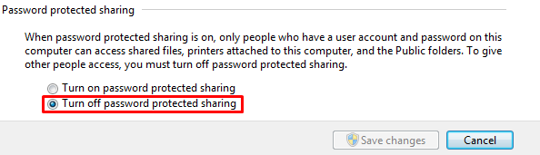

* + 1. If it does not connect, follow (step b) above again but substitute the hostname with the IP Address (Part I, Step 5(b)).
    2. If it still does not connect, make sure the computers are on the same network/workgroup/domain (you can see this in the Computer Properties dialog you used to find the computer name in Part I, Step 5(a).
    3. You can try to ping the server PC, but if you get to this stage, you may ask the client to contact their IT guys to try and resolve the connection issues.
  1. Right-click the Africa folder, and select “Map as network drive”

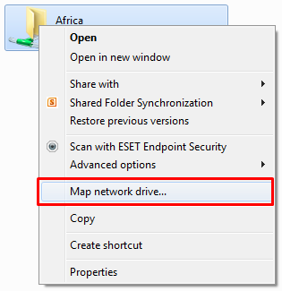

* 1. You may choose any network drive letter from drive H and onwards (drives A and B are legacy drive letters, and C – G is usually used for local disks, optical drives, and removable storage devices).   
     **Drives X and Z are good choices.**

1. The FMA icon and license setup are as follows:

|  |  |  |
| --- | --- | --- |
| **CLIENT-PC** | **PROGRAM PATH** | **DATA PATH** |
| **ICON** | **X** | C |
| **LICENSE** | **X** | **X** |

**NB: MAKE SURE THE ICON AND LICENSE PROGRAM AND DATA PATHS ARE CORRECT!**

*For instance, if the icon data path = X, the license of the server will be overwritten!*

***Important note – On the Client PC, using a program path of ‘C’ for the icon and license is possible, but there is a bug where not all of the databases are linked correctly to the data path of ‘X’.***

***Thus, some database changes are saved to the data path ‘X’ – correct, while other changes are only saved locally ‘C’ – incorrect, which is a major issue!***

***Affected modules (as far as we know of, there could be others): Pest Monitoring***

**SUMMARY**

|  |  |  |
| --- | --- | --- |
| **SERVER-PC** | **PROGRAM PATH** | **DATA PATH** |
| **ICON** | C | C |
| **LICENSE** | C | C |

|  |  |  |
| --- | --- | --- |
| **CLIENT-PC** | **PROGRAM PATH** | **DATA PATH** |
| **ICON** | **X** | C |
| **LICENSE** | **X** | **X** |