


FARM MANAGEMENT AFRICA MAIN MODULE

STUDY GUIDE

T: +27 21 874 1047
sales@donkerhoekdata.co.za support@donkerhoekdata.co.za
Simondium Guild - R45 - Simondium
www.donkerhoekdata.co.za



Who is Donkerhoek Data?
It all began in 1982 on the farm Donkerhoek, situated in Simondium. Farmer Robert Koch developed and introduced specialized agricultural software to the industry.

Today this innovation still continues, making Donkerhoek Data an industry-acknowledged service provider to more than 1,000 clients. Donkerhoek Data also offers comprehensive hardware services.

The Payroll Africa User Manual
Do consult our extensive user manual. It offers information on using Payroll Africa’s program functions and has search facilities.

This symbol indicates which section in the manual has more information on the particular topic. Updates will be made available on our web page.

Avoid high bank charges with
We advise clients to use Paysoft for electronic payment transfers. You pay a ﬁxed price per transaction with Paysoft. Transaction fees are lower than what the banks charge and there are no monthly or hidden costs.

Paysoft offers tight security and is just as safe as electronic banking. You can also use it to pay your debtors. An appointed staff member will gladly give a demonstration at a time that suits you.

Other Donkerhoek Data Products
Farm Management Africa
Spray, fertilizer, record keeping and reports, pest monitoring, vehicle register, GlobalG.A.P., Nature’s Choice, IPW, IPM points.

Income Module
Speciﬁc income per block can be allocated.

Payroll Africa
User-friendly Payroll (Wages and Salaries) for the farm, cellar, or business. Additional hardware that handles time and attendance, as well as piecework, can be incorporated.

FARM MANAGEMENT AFRICA MAIN MODULE
STUDY GUIDE

Home Screen

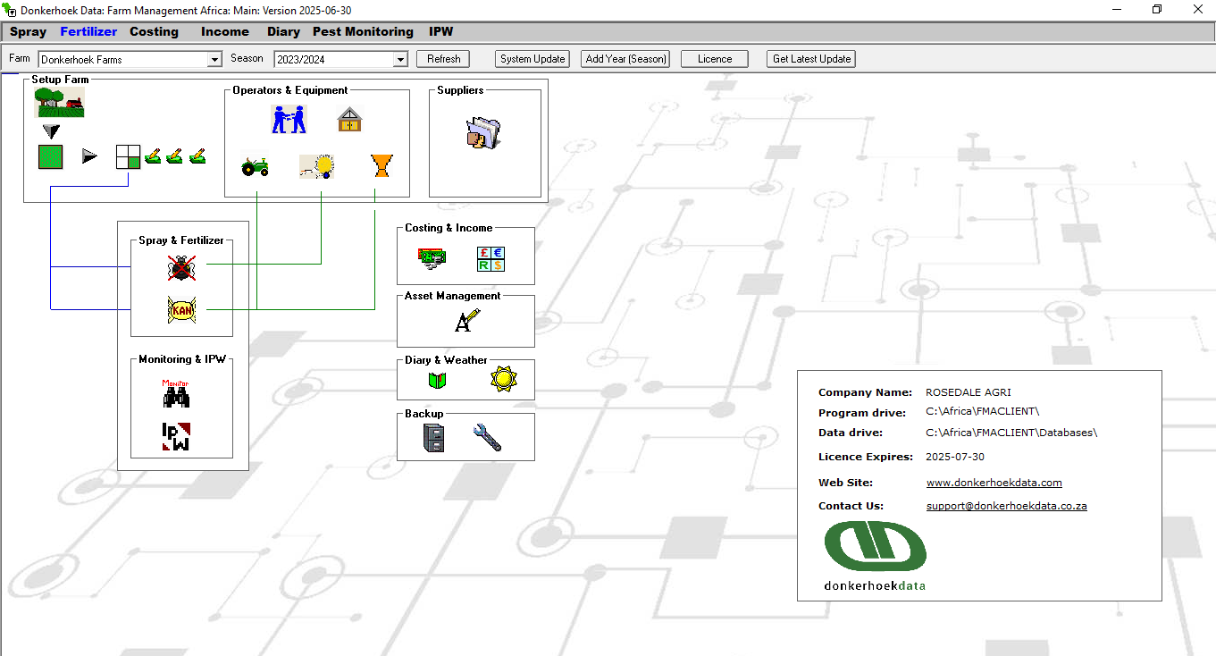

Farm Management Update Process

- Ensure that your program is closed when doing an update.
- Open www.donkerhoekdata.co.za and navigate to the “Updates” option.
- Scroll down to the Farm Management section and choose one of the options available: Download FMA Update to update the program and WP Update to update the withholding periods.
- When the file is finished downloading, run the file and click on OK.
- Open the Farm Management program and click on the button at the top, “ System Update”, and click on Update at the bottom. The update process will begin, and messages will appear. Click on the close button when the update is completed.
- Alternatively, click on the Get Latest Update button, and the program will close and open the website for you to download the update.

IMPORTANT

When you have multiple network connections to the program, make sure all the programs are closed on all the computers before doing the update. After the update, make sure all the programs on all the computers have been updated and are on the same program versions.

Creating a New Season

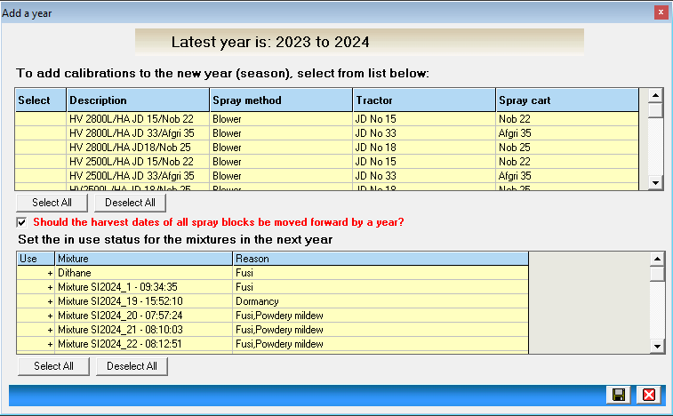

- To create a new season, navigate to the main module screen and click on the button “Add Year (Season)” at the top.
- Select/deselect the calibrations you wish to copy over to the new season.
- Select/deselect the mixtures you wish to copy over to the new season.
- Should the harvest dates be moved forward, automatically selected, meaning that all the spray block harvest dates will be adjusted within a year.
- Click on Save, and the new season will be created.

Backup

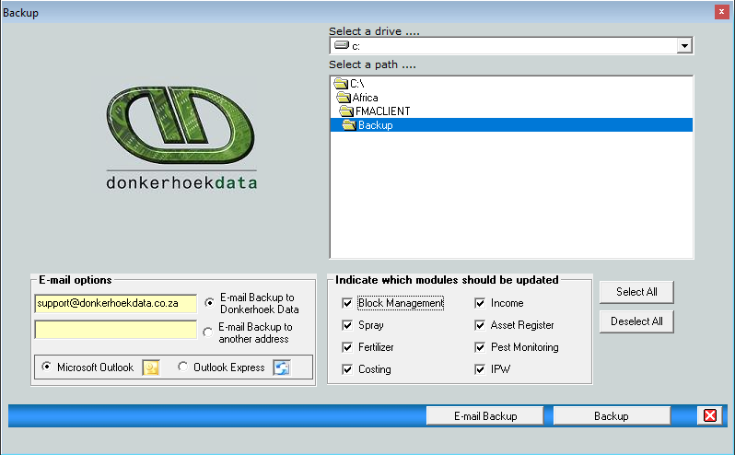

- To make a backup, click on the “File Cabinet” icon on the main module to access the above screen.
- The path where the backup will be created will be displayed; you can select another path or an external drive.
- Indicate which modules should be updated. Select All” at this option so that all the modules in the program are selected for a backup.
- Email Backup, to email the backup to Donkerhoekdata or Backup to make the backup on your computer.

Setup Farms

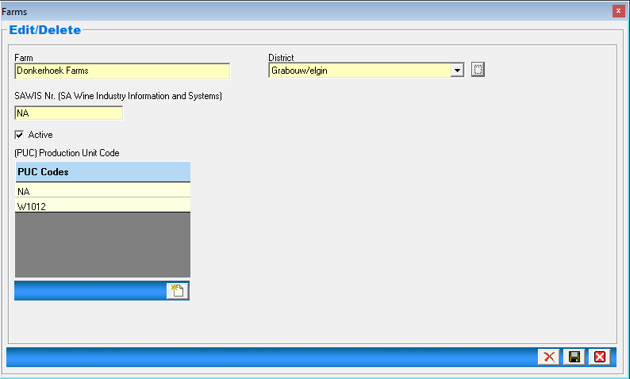

- Farm – Type in your farm/company name.
- District – Select the district your farm falls under. (If your district is not on the list, add our district to the button next to district and select it in the drop-down.)
- SAWIS – Type in your SAWIS number (SAWIS’s purpose is to assist the wine industry by turning data into information)
- Active – Your farm can be made inactive at any time; take out the active tick, and the system will make the farm inactive with both its chemical and fertiliser stores.
- PUC – Type in your production unit code.
- Click on Save to save your farm or changes.

IMPORTANT

You can add multiple farms to the program, as long as each farm has its own chemical and fertilizer store. If a farm does not have its own chemical and fertilizer store, then that farm's blocks should be set up under another farm to function correctly.

Setup Main Blocks

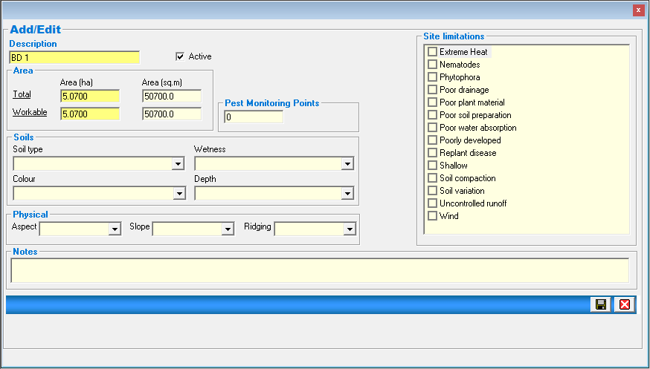

- Description, add the name of the block (the name can be edited in the future)
- Make sure the active tick box is marked.
- Total & Workable Area, type in the hectares of the block in both fields. If the workable hectares are smaller than the total hectares, adjust accordingly.
- Notes: here you can type in any additional information about the block you would like to remember.

IMPORTANT

The rest of the information that you can add to the main block setup screen is optional and is there only for additional information regarding the block.

Number of Monitoring Points

If you use the Pest Monitoring Module, then you will have to add the number of pest monitoring points that the block has under the setup of the main block. These numbers of points will pull through to the pest monitoring module.

Setup Spray Blocks

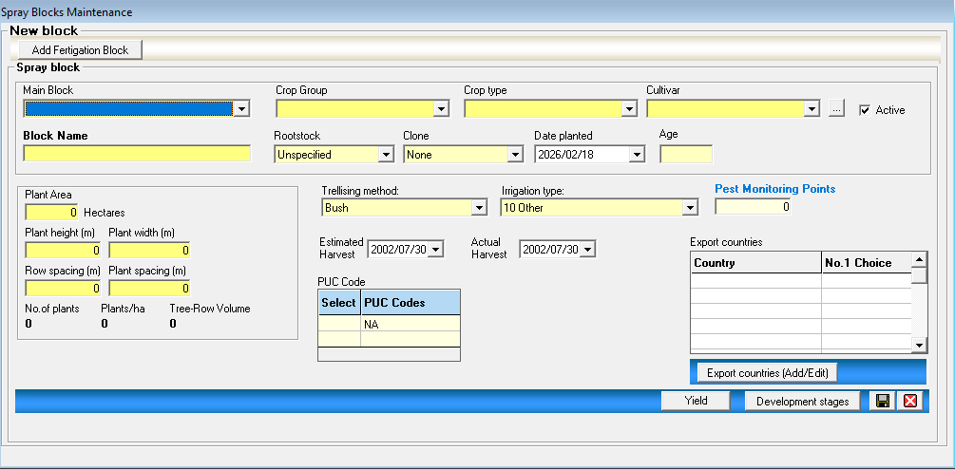

- Main Block, select the main block under which the spray block would fall.
- Crop Group/Crop Type/Cultivar, select from the drop-down what you have planted on this specific block. (If what you want is not under the drop-down, add your cultivar under the button next to the cultivar drop-down)
- Active tick, automatically selected. If this block has been cut out or replaced by another cultivar, remove the tick and save. The block will then be made inactive, and you can add the new block with its details.
- Block Name, type in the description/name of the spray block. (This name will appear throughout all the modules) The name can be edited at all times.
- Rootstock & Clone, select from the drop-down or keep the default selection.
- Date planted & Age: type in the plant date of the block, and the age will be automatically calculated.
- Trellising method and irrigation type, select from the drop-downs applicable to the block being set up.
- Estimate & Actual Harvest Date: type in the harvest date for the block being set up. Both can be on the same date and edited throughout the season as needed.
- PUC Code, select the correct PUC code by putting a + sign next to the PUC.
- Plant area: The plant area is automatically pulled through from the main block you have selected. (The hectares can be adjusted to smaller hectares if the block is being split into smaller blocks)
- Plant height /Plant width/Row spacing & Plant spacing, these is the actual meter dimensions of the trees and rows in the block.
- Export countries, click on export countries (add/edit) to select a country in the list. You can have multiple selections, but only one default country. The default countries ’ MRLs will be used in the spray module when spraying the block.
- Development stages “button” see the print screen below, here you can add 3 different development stage names, with from and to dates.
- Yield button, here you can add the block yield, multiple entries allowed, see print screen below and setups.
- Pest Monitoring Points, add the spray block’s number of pest monitoring points here; this will pull through to the pest monitoring module for you to use.
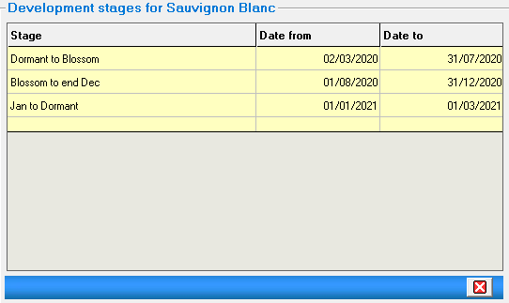

This field under the Development stages section represents your block's “Full Bloom” date. The full bloom date only appears on your Spray records report in the Spray Module.

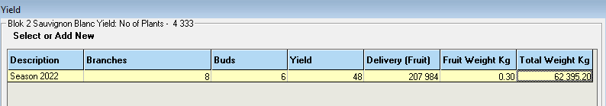

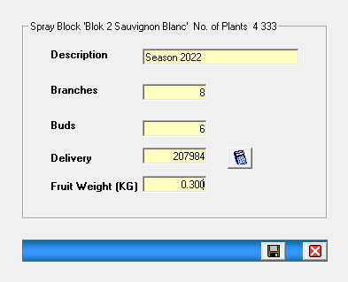
- Description: type in any description for this yield transaction.
- Branches, enter the number of branches on the tree.
- Buds, enter the number of buds on each branch.
- Delivery, yield (branches times buds), times number of trees. (You can enter your number of trees, or click on the calculator to use the number of trees, as set up under Setup Spray Blocks).
- Fruit Weight (KG), enter the weight of a fruit for this transaction.

Setup Fertigation Blocks

- - open a spray block, at the top click on the Fertigation button.

- 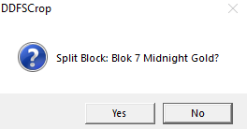 - Message will appear, click on Yes if you want to continue.

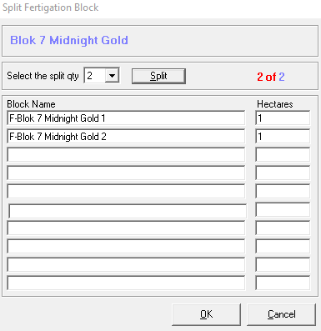

- Click on Select the split qty and choose how many blocks you want to split your fertigation block, and click on OK.
- 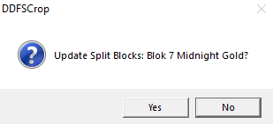 - Message will appear, click on Yes.

- 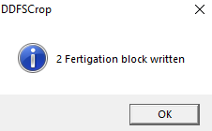 - Message will appear, click on OK.

- 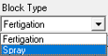 - to see your fertigation blocks, when opening the spray block icon, at the top, there will be a Block Type drop-down, select Fertigation, and the list of Fertigation blocks will display as seen below, for example.

Setup Workers

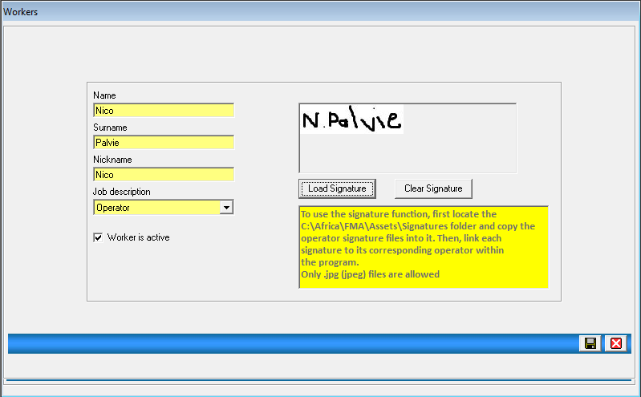

- Type in the name/surname and Nickname of the operators you use when spraying chemicals or applying fertilisers.
- Job description, Operator automatically selected when adding a new worker; other options available.
- Worker is active, you can take out the active tick, and the operator will be made inactive and will not be available to be used further in the program.
- Load and clear signature, follow the on-screen directions to add a signature to the operator, which will automatically print on the spray and fertiliser instructions.

Setup Stores

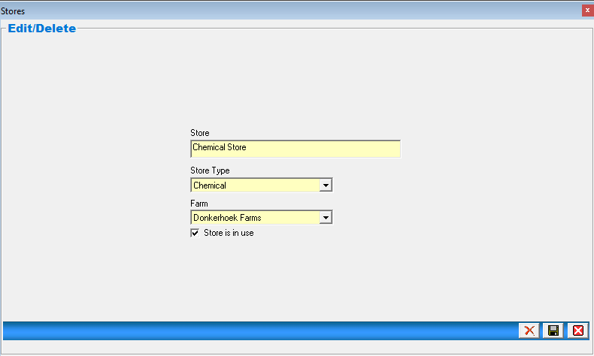

IMPORTANT

The stores are set up by Donkerhoekdata when the program is installed on a client’s computer. Both Chemical and Fertiliser Stores will be set up. The Farm Management Program cannot function without both of these two stores.

- Store, type in the name of the specific store.
- Store Type, select from the drop-down list if it is a Chemical or Fertiliser store being set up.
- Farm, select from the drop-down the farm you wish to link this store to.
- Store is in use; this tick will be in to show that it is an active store.

Setup Tractors

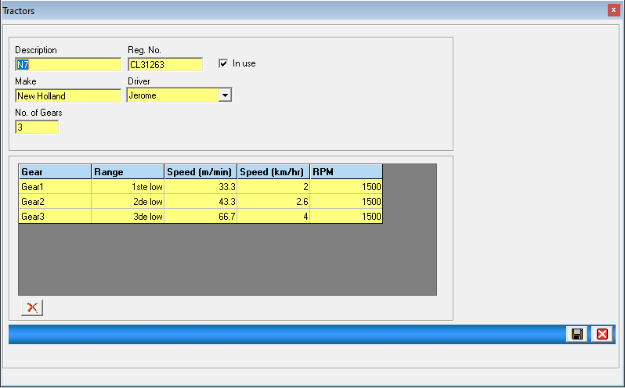

- Description, type in the name of the tractor being used on the farm, specifically for chemical spraying purposes and applying fertilisers through means of a spreader on the farm.
- Reg. No, type in the registration number of the tractor. If the tractor does not have one, you can type in any other information regarding the tractor.
- Make, type in the make of the tractor.
- Driver, select the default driver for this tractor from the drop-down list.
- No. of Gears, type in only the number of gears you use on this tractor, for when you are spraying chemicals with it, you do not have to add all the tractor gears.

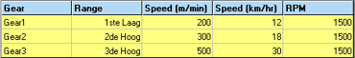

- Gear column, Gear 1, etc., leave this column as is; this only indicates the row.
- Range, in this column, you must type in the gear name; see the example in the print screen above.
- Speed (m/min) and speed (km/hr), type in the information for one of these columns; when the value is added to the other columns, the value will be calculated.
- RPM, type in the refs per minute for that specific gear.

Setup Spray Carts

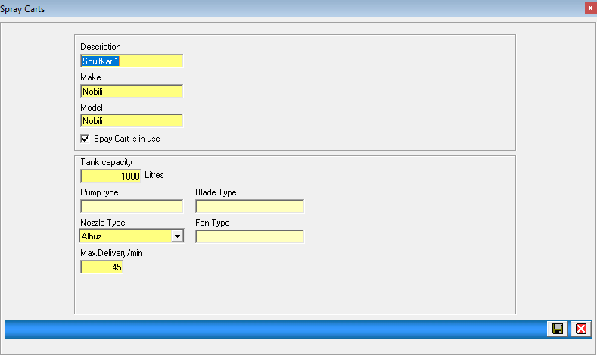

- Description: type in the name of the spray card.
- Make and model, type in the information that is available to you.
- The spray cart is active, filled automatically, and can be taken out of the spray cart is no longer is use on the farm.
- Tank capacity, type in the size of the spray tank in Litres.
- Pump/Blade & Fan Type, these fields are optional.
- Nozzle Type, select from the drop-down list which type of nozzles are being used on this spray cart.
- Max. Delivery/min, type in the maximum litres per minute that the spray cart can spray.

Setup Spreaders

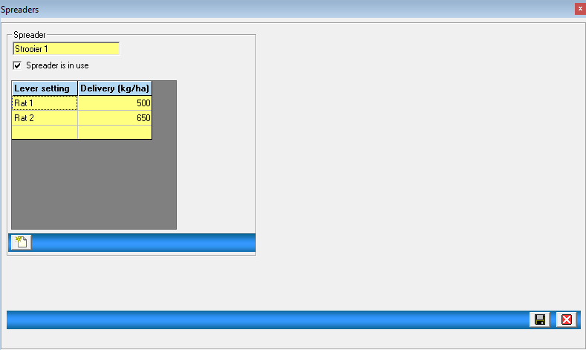

- Spreader, type in the name of the spreader being used on the farm.
- Spreader is in use, tick automatically in. If the spreader is not being used, remove the tick and save.
- Lever setting & Delivery (kg/ha), click on the “add new” button at the bottom to add your different lever settings, type in the lever setting name, and next to it, the kg/ha that the setting delivers.

Setup Suppliers

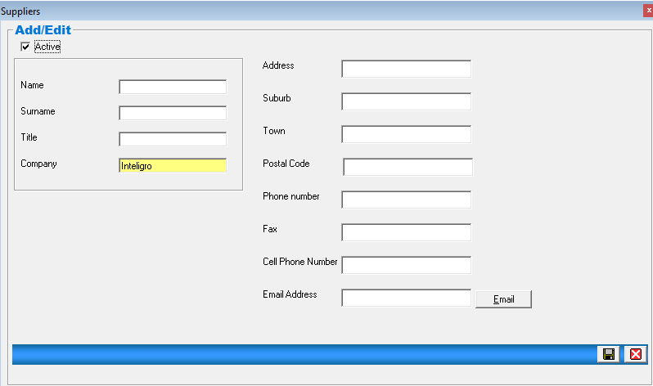

- Company, type in the company name from which you buy your chemicals and fertilisers.
- All other information fields are optional and give you extra information about the company you buy from.
- Suppliers can be made inactive at any time. Make sure that no products in both the spray module and fertiliser module are linked to the supplier.

Diary

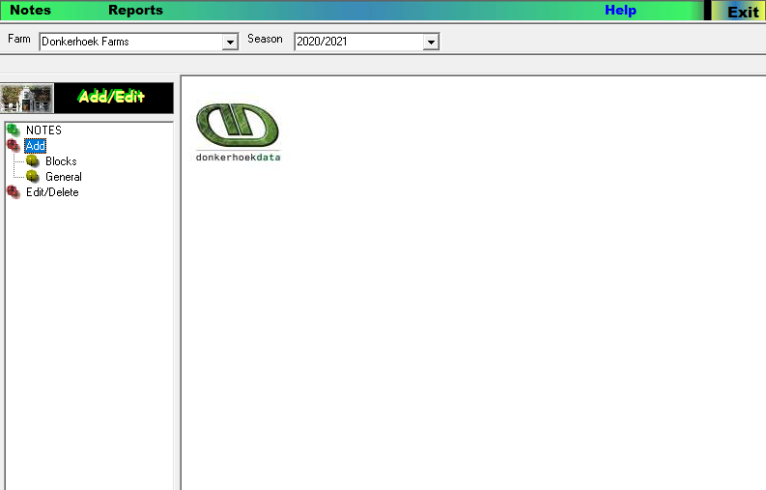

- Under the Diary Module you can add General Notes and Notes towards a specific block.
- You will get the option “Add”, and you will have to choose if it is for a block or general.
- Blocks, if selected, the main block drop-down list appears, and you have to choose the main block. From this, the spray blocks will appear for you to select the correct spray block to make the note for. Upon clicking on the spray block, a note screen will come up for you to fill in, select the date, type in a reference number, and you can add a cost (this will pull through to the costing module and die spray block transaction report), type in a subject, and under notes, you can add detail.
- General, under the general notes, the same screen for notes will appear, but just without selecting any blocks.
- Edit/Delete: All notes added can be edited or deleted under this option.
- Reports, you can print all the general notes, or for a specific block you selected.

Weather & Rainfall

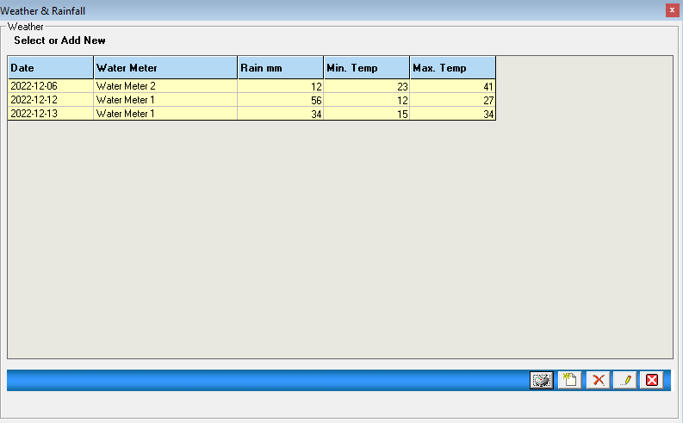

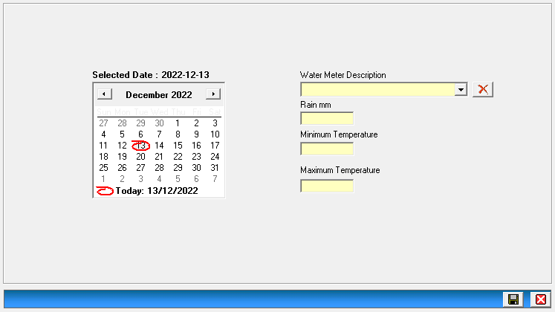

- Select date
- Water Meter Description, type in any description (multiple descriptions allowed to choose from drop-down)
- Rain mm, type in the rainfall millimeters
- Minimum Temperature: type in the minimum temperature measured.
- Maximum Temperature: type in the maximum temperature measured.

Weather & Rainfall Report Example

