


FARM MANAGEMENT AFRICA SPRAY MODULE

STUDY GUIDE

T: +27 21 874 1047
sales@donkerhoekdata.co.za support@donkerhoekdata.co.za
Simondium Guild - R45 - Simondium
www.donkerhoekdata.co.za



Who is Donkerhoek Data?
It all began in 1982 on the farm Donkerhoek, situated in Simondium. Farmer Robert Koch developed and introduced specialized agricultural software to the industry.

Today this innovation still continues, making Donkerhoek Data an industry-acknowledged service provider to more than 1,000 clients. Donkerhoek Data also offers comprehensive hardware services.

The Payroll Africa User Manual
Do consult our extensive user manual. It offers information on using Payroll Africa’s program functions and has search facilities.

This symbol indicates which section in the manual has more information on the particular topic. Updates will be made available on our web page.

Avoid high bank charges with
We advise clients to use Paysoft for electronic payment transfers. You pay a ﬁxed price per transaction with Paysoft. Transaction fees are lower than what the banks charge and there are no monthly or hidden costs.

Paysoft offers tight security and is just as safe as electronic banking. You can also use it to pay your debtors. An appointed staff member will gladly give a demonstration at a time that suits you.

Other Donkerhoek Data Products
Farm Management Africa
Spray, fertilizer, record keeping and reports, pest monitoring, vehicle register, GlobalG.A.P., Nature’s Choice, IPW, IPM points.

Income Module
Speciﬁc income per block can be allocated.

Payroll Africa
User-friendly Payroll (Wages and Salaries) for the farm, cellar, or business. Additional hardware that handles time and attendance, as well as piecework, can be incorporated.

FARM MANAGEMENT AFRICA SPRAY MODULE
STUDY GUIDE

Spray Module

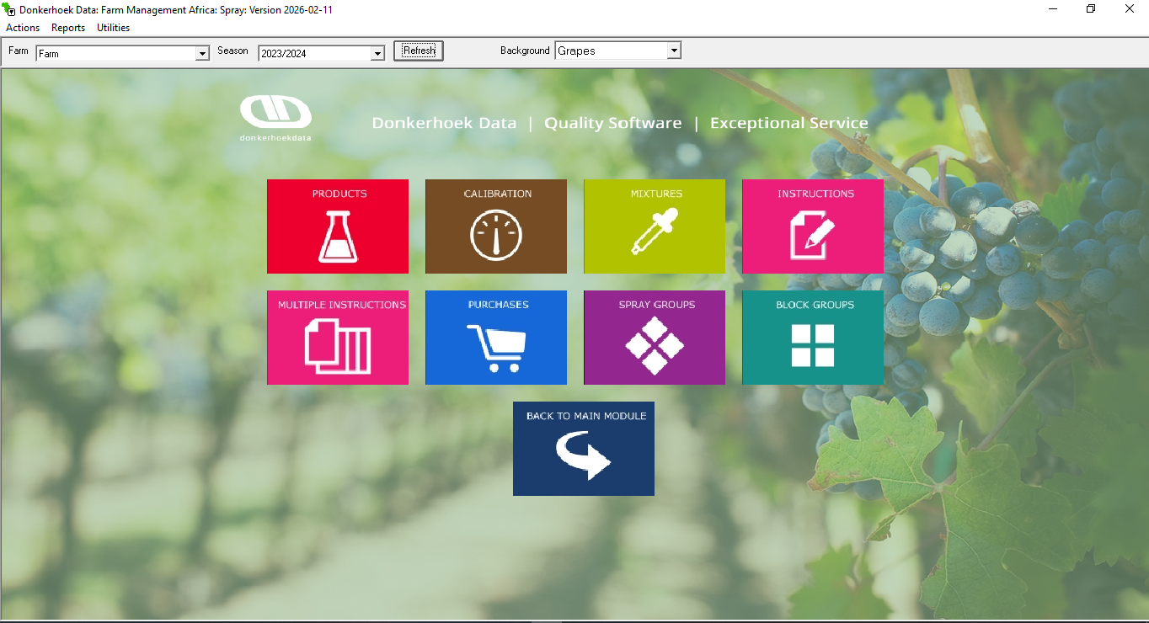

- Main Screen

- Menu Item: Actions – The same functions as indicated by the Icons are found under this menu item.
- Menu Item: Reports
- Menu Item: Utilities – Integrity Check (for Donkerhoekdata use only) + GlobalG.A.P. Number (add your GGN number here) + Refresh Farm Tables (use this button to refresh all tables when something is missing) + Log File (file for when you have changed withholding periods manually) + Preferences + Custom Active Ingredients (for adding your own active ingredients and withholding periods)
- Farm – A dropdown option where the farm can be selected.
- Season – A dropdown option where the season can be selected.
- Refresh – Click on this button whenever you want to return to the main spray module screen.
- Dropdown (Grapes/Apples, etc.) – Background Wallpaper

- Chemical Products
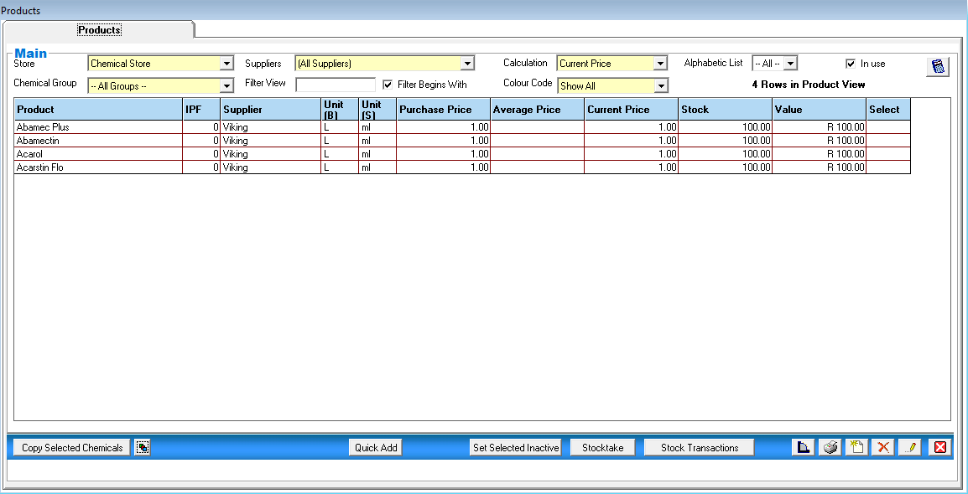

On the product screen, you have the following options:

- Filters at the top – Store, Chemical Group, Suppliers, Calculation, Colour Code
- Search View - search for a specific chemical in the list.
- Copy Selected Chemicals Button - if you have multiple farms or stores, you can use this option to copy a chemical's setup from one farm to another.
- Stock-take Button - doing a stock take for all your chemicals.
- Quick Add – option to add multiple new products.
- Set Selective Inactive – select multiple products and click on this button to make them all inactive. The same option for when you make multiple products active.
- Stock Transactions Button - displays all transactions for the selected chemical. You can also edit price averages for historical purchases for the selected product.
- Purchases Button - shortcut to chemical product purchases.
- Print Product Report prints the list of chemicals as seen on the screen, with all the columns in the grid.
- Standard Buttons - Add new, Delete, Edit, and Close.

- Product Setup
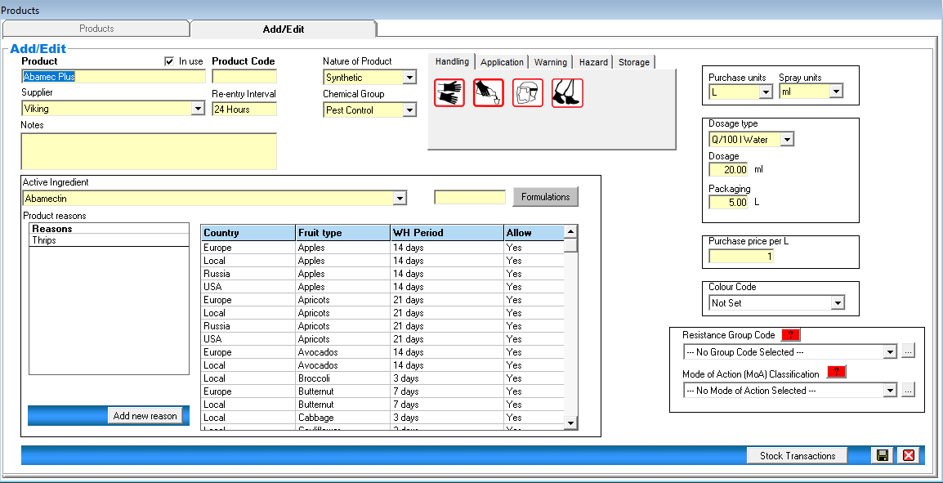

- Product - Insert your product name
- Product Code - Insert the code for the chemical product, if available (optional).
- Supplier - select the supplier from whom you are buying this product.
- Notes - type anything you want to remember for this product.
- Nature of Product – select from the drop-down the nature of the product.
- Chemical Group - Select the group under which this product falls.
- Active ingredient - select the active ingredient of the chemical product from the dropdown list. This, in return, will populate the Allowance list with the relevant withholding periods.
- Formulation – type in the formulation of the active ingredient, for example: “23ml/L”
- Formulation Button – Setup for the total active ingredient applied. (see below)
- Product reasons - select from the drop-down list the reason for applying this product.
- Chemical Images - select the appropriate pictures linked to the product in all sections. (By default, all chemical images will be selected)
- Purchase units - Select the units you buy this product in.
- Spray units - select the units you spray this product in.
- Dosage type - select from the dropdown list how this product will be applied.
- Dosage - type in the dosage for the chemical according to the dosage type.
- Packaging – complete the packaging size of the chemical product.
- Purchase price per - type in the price per purchase unit.
- Colour Code - select the colour code for this chemical product.
- Resistance Group Code – add a new group code and select from the drop-down.
- Mode of Action (MoA) Classification – add a new action and select from the drop-down.

Setup of Formulation (Total Active Ingredient Applied) – see Spray records report – Total Active Ingredient Applied
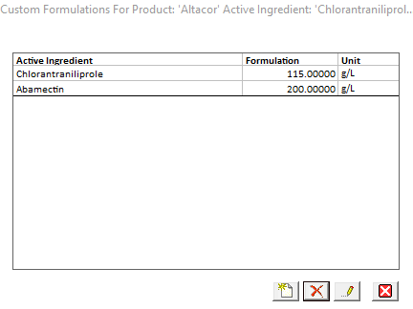
When selecting the Formulation button, this screen will appear, pulling through your active ingredient selected. Edit the active ingredient, and then the following screen will appear. You can edit the custom active name and then type in the formulation and select the unit it has. Save.
When an active ingredient, like in this screenshot has two active ingredients, you first edit the active ingredient once clicked on formulations and edit the custom name to be only the first active name and enter its details and save, then you add another custom active ingredient and edit the name to the other active ingredients name and type its formulation and unit in and save.

See examples below on how it must be done if two active ingredients are present.
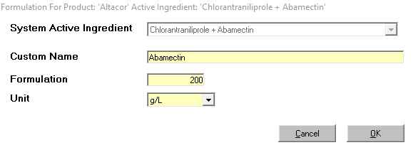
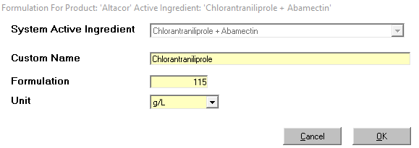

- Stock Take

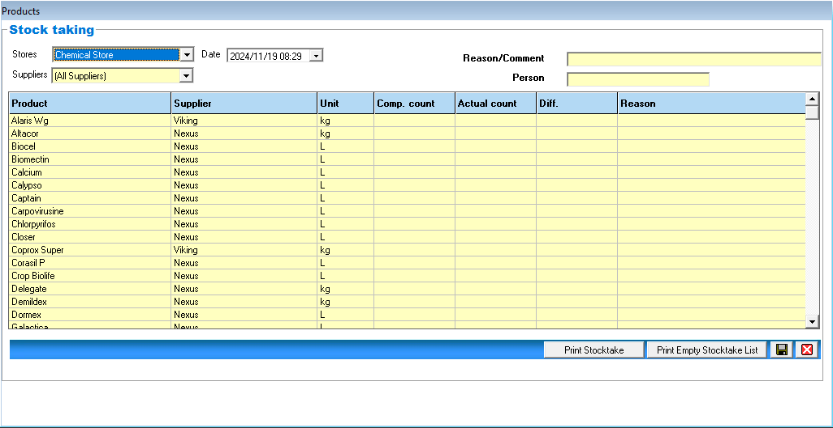

- Stores & Suppliers dropdowns - automatically set to “All”, but can be changed to specific stores and/or suppliers.
- Date - select the correct date when the stock take was done.
- Reason/comment - type in the reason for the stock take.
- Person - type in the name of the person taking the stock.
- Comp. count - shows the stock value that the program has calculated.
- Actual count - in this column, enter each product’s current stock take value.
- Print stock-take - print the stock-take values you have captured.
- Print Empty stock-take list - prints an empty stock list form to use when taking your actual stock in the store.
- Save button - saves the stock take values and adds the actual count of each product to your chemical products.

- Purchases

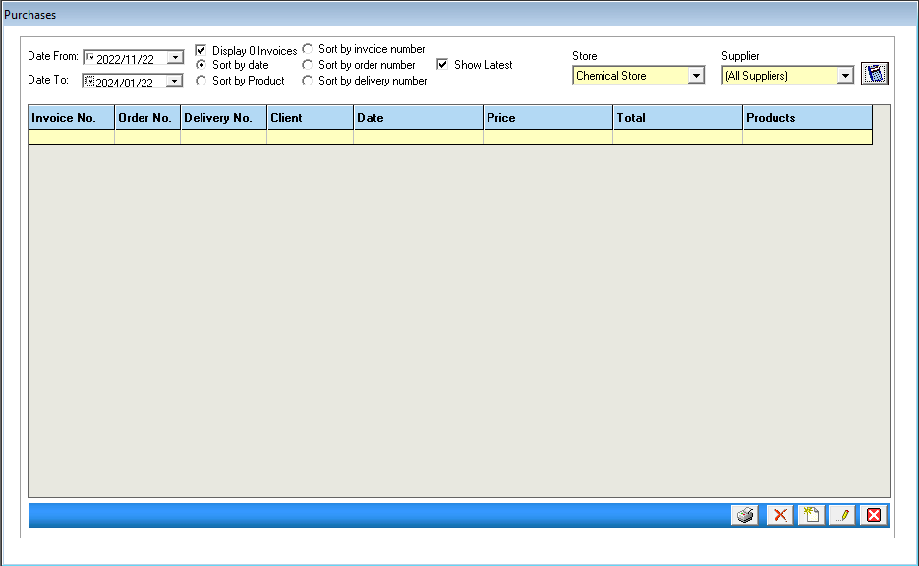

- Date From / Date To - select the date range to view purchases.
- Display/Sort buttons - select how you want to view your purchases.
- Store - select which store purchases should be displayed.
- Supplier - select which suppliers’ purchases should be displayed.
- Apply Filter - click on the Apply Filter button to apply your selection.
- Add a new button - to add a new purchase.
- Delete Button, delete the purchase and reverse the stock.
- Edit button – to edit a purchase.

- New Purchase

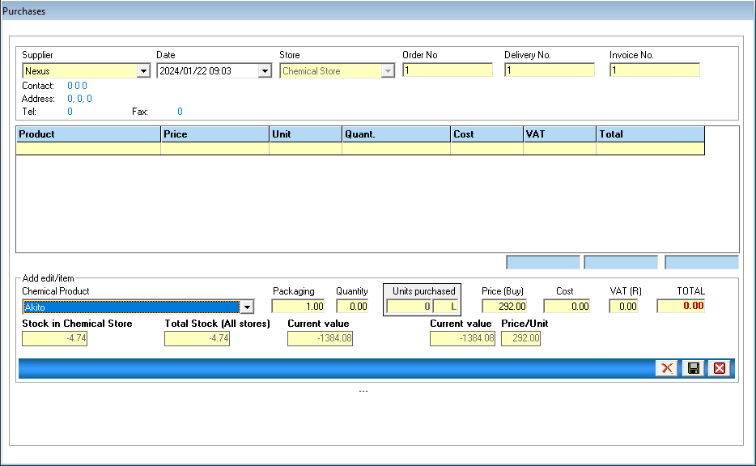

- Supplier - select the supplier for the purchase you are capturing.
- Date - select the date of the purchase.
- Store - select the store.
- Order No - type in an order number if you have one.
- Delivery No - type in a delivery note number if you have one.
- Invoice No - type in your invoice number. This number can be added at a later stage, when you get the invoice, by editing the purchase.
- Click on the Add Product button at the bottom to add the products you have purchased.
- Chemical Product - select the chemical product from the dropdown list.
- Packaging – this is automatically completed, according to the product’s setup.
- Quantity - type in the number of packaging units you have purchased for this product.
- Units purchased – this will be calculated automatically to show you the number of units purchased.
- Price Buy - edit if the price per purchase unit has changed.
- VAT can also be added
- Total - shows the total price for the quantities purchased of the product.
- Click on save to add the product to the purchase.
- Click on save to save the purchase.
- Delete button, if you have added the wrong product to the purchase, select the product and click on delete. The product will then be deleted from this purchase, and the stock will be reversed.

- Calibrations

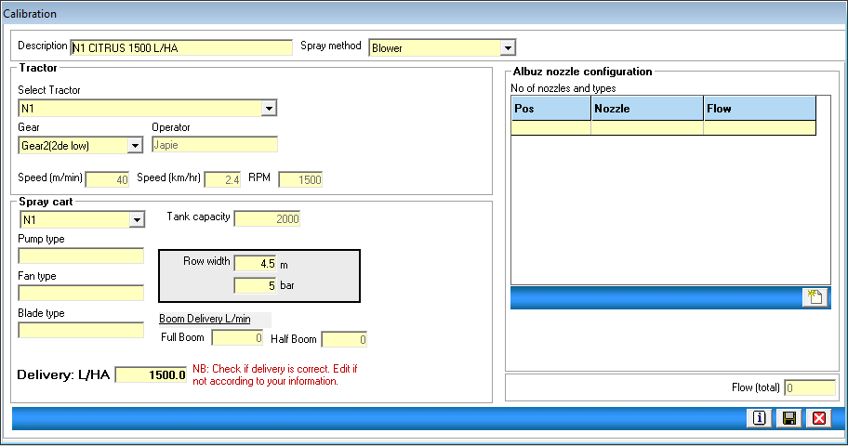

- When adding a new calibration, the above screen will appear.
- Description - Enter a name for the calibration.
- Spray method - select a spray method from the dropdown list.
- Select Tractor - select a tractor for this calibration.
- Gear - select the correct gear.
- Spray cart - select the spray cart for this calibration.
- Row width - Enter the row width for which this calibration will be used.
- Bar - Enter the pressure (in bar) at which you will be spraying.
- Delivery: l/ha - Enter the volume for this calibration.
- Save the calibration.
- After saving the calibration, reopen the calibration, and you will have the option to specify the nozzles for this calibration on the right-hand side of the screen. Please contact Donkerhoekdata for further assistance.
- Boom Delivery L/min will only be calculated if the nozzles have been specified.
- Transfer to another season - option to transfer this specific calibration from one season to another.

- Mixtures

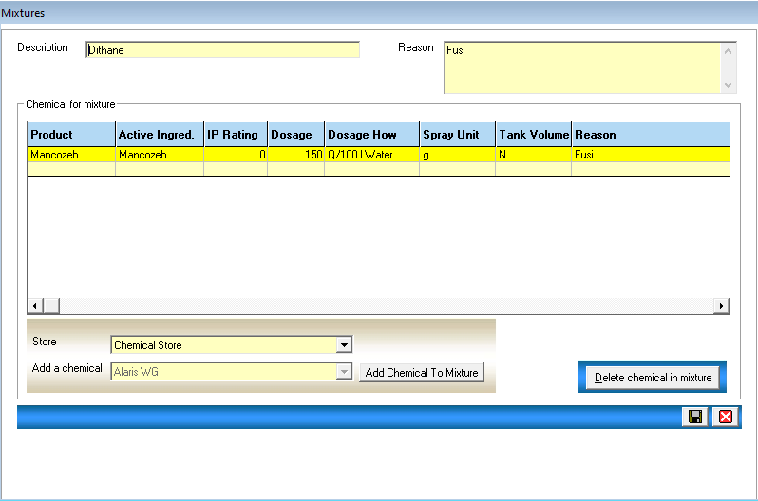

- Description – Enter a name for the mixture.
- Reason - this will be completed automatically when the chemicals for this mixture is selected.
- Store - select a store from the dropdown.
- Add a chemical - From the dropdown list, select the chemicals you want to add to the mixture. Select each chemical and click on the button to add the chemical to the mixture.
- Delete chemical in the mixture - if you have incorrectly selected the wrong chemical for the mixture, select the chemical in the list and click on this button to remove the chemical from the mixture.
- Save the mixture.

- Block Groups

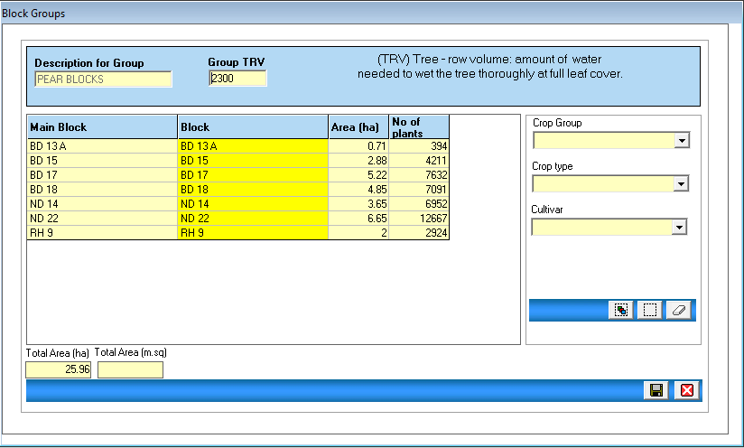

- Description for Group – Enter a description for the block group.
- Group TRV – The tree row volume for the group.
- Crop Group / Crop Type and Cultivar - use these filter options to generate the list of blocks on the left-hand side.
- Select the blocks you want to add to this group (they will appear in yellow)
- Save the group.

- Spray Groups

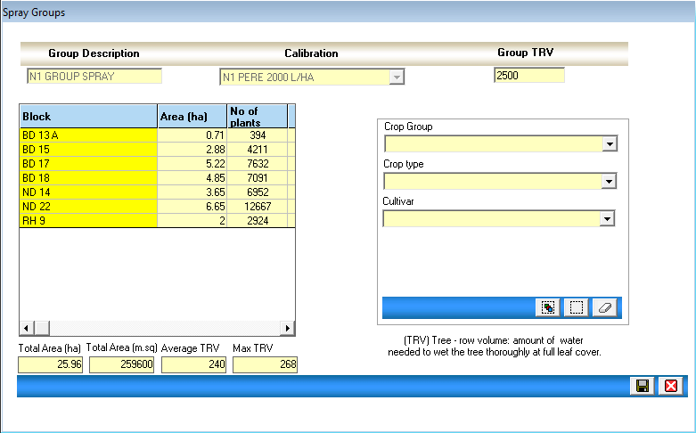

- Group Description – Enter a description for the spray group.
- Calibration - select a calibration from the dropdown list for this group.
- Group TRV - Enter the tree row volume for the group.
- Crop Group / Crop type and Cultivar - use these filter options to generate the list of blocks on the left-hand side.
- Select the blocks you want to add to this group (they will appear in yellow)
- Save the group.

- Instructions

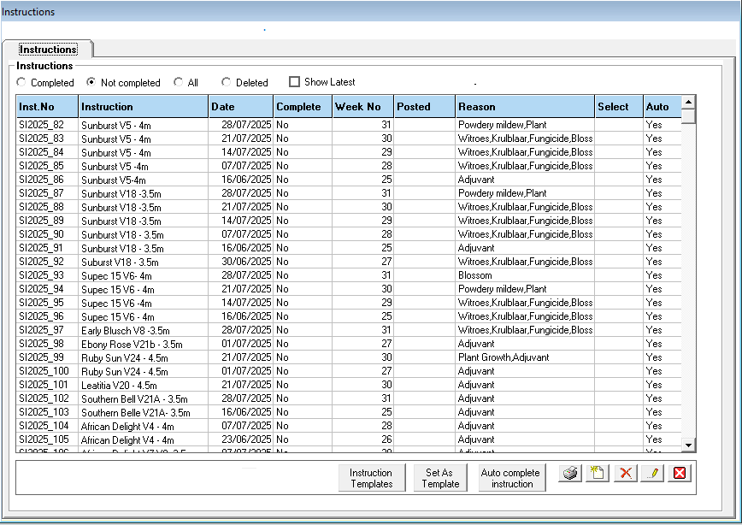

- When you click on the “Instructions Icon”, the above screen will appear.
- Completed/Not Completed/All and Deleted – These are different filter options for all your instructions.
- Auto Complete instruction - when entering an instruction, you have the option to select the Auto Complete tick-box. This will allow the user to make use of the AutoComplete function.
- Simply select the open instructions and click on auto-complete. Then select the store and click on “Save”. The instruction will then be completed as is with no changes made by you.
- The selected instructions will then automatically be completed, and stock will be deducted from the chemical store.
- Print selected instructions - Select the instructions you wish to print from the list, and click on the print button. Each of the selected instructions will then be printed in Excel. A confirmation message will be displayed once all the instructions have been printed.
- Click on the delete button to delete an open or closed instruction. Stock from closed instructions will be transferred back to the chemical store once it has been deleted.
- Click on “Add new instruction” to enter a new instruction.
- Set As Template – You can save any instruction as a template. Select the instruction and click on Set As Template. The template instruction will then be listed under Instruction Templates.
- Instruction Templates – select Instruction Templates, and the frame will appear listing all the templates you have created. You can select the specific template and then either delete the template or create a new instruction. If a new instruction was created, the instruction will be listed under your open instructions, and you can edit the date for this new instruction and continue as normal.

- New Instruction

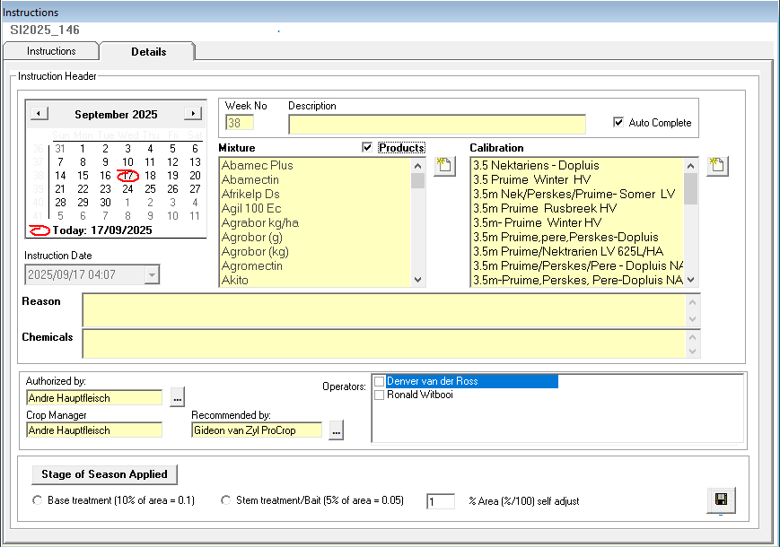

Instruction details tab:
- Select the recommended spray date – the week number will be completed automatically.
- Description – describe the instruction.
- Auto Complete – Tick this field if you want to auto-complete the instruction at a later stage.
- Mixture – select a mixture or add a new mixture using the shortcut.
- Products tick box – by selecting this, your list of products will be listed for you to select the products you want to use in this instruction. You can either choose a mixture or you can choose multiple products.
- Calibration – select a calibration, or add a new calibration using the shortcut.
- Reason - completed automatically when selecting the mixture.
- Chemicals – completed automatically when selecting a mixture.
- Recommended by/Authorised by and Crop Manager - enter the relevant names, and they will remain there until you change them.
- Operators – an operator is automatically selected when selecting a calibration. You can change the operator by selecting another operator.
- Base/Stem Treatment - only select this field if using the IPW module.
- Save Instruction Details – after saving, the next screen will appear.
- TAKE NOTE – once you have saved an instruction, you can open it again and edit everything if you have made a mistake.
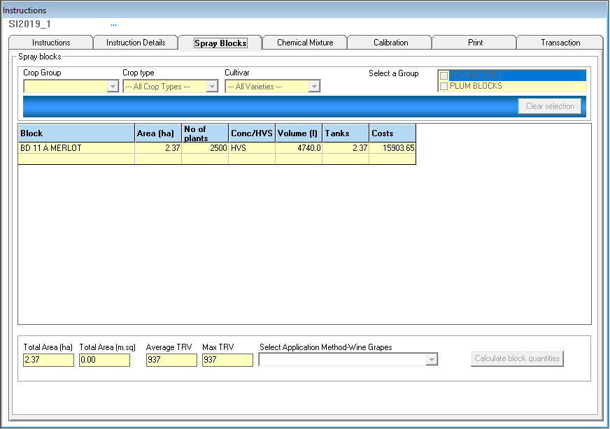

Spray Blocks tab:
- Select Crop Group, Crop Type, etc. to show the applicable spray blocks.
- Select all/De-select all – use these options to select or deselect all blocks in the list.
- Clear selection – when selecting this option, your selected blocks will be removed from this instruction, and you can select new blocks.
- Select the blocks for this instruction by clicking on them (on selection, they will turn yellow)
- Select Application Method-Wine Grapes - this option will only be available if a wine grape block has been selected. Choose the correct method of application and continue.
- Calculate block quantities - click on this button after you have selected the blocks to be sprayed. This will calculate the total hectares to be sprayed.
- Next, the Chemical Mixture screen will appear.

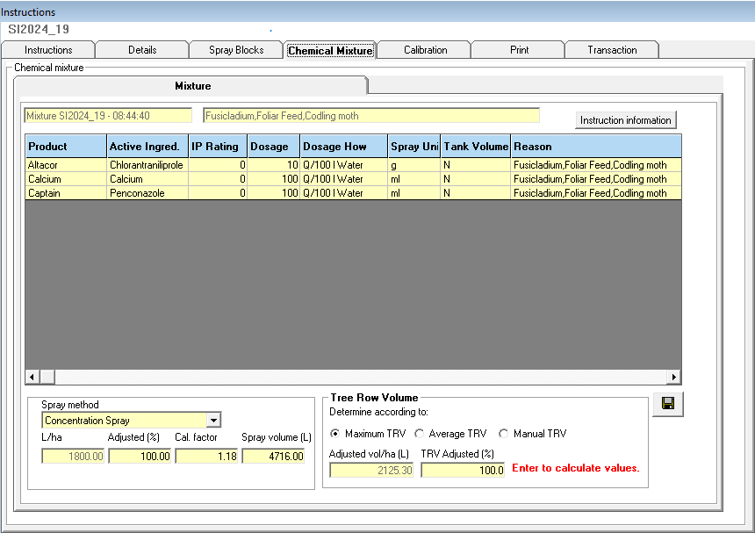

Chemical Mixture tab:
- The mixture details, with the chemicals in the mixture, will appear on this tab.
- In the list of chemicals, you can edit the Dosage of each product.
- Spray Method - select High Volume Spray or Concentration Spray.
- High Volume spray is a normal spray where the program looks at the total hectares and multiplies the L/Ha with it to calculate the Spray volume, and then looks at the product dosages and calculates the amount of product needed.
- Concentration Spray does the same as the high-volume spray, but here you can adjust the TRV % of what you are spraying, and the dosage of the products will be adjusted according to this %. Always remember to press Enter when you have edited the Adjusted Volume per hectare and the TRV Adjusted %.
- Instruction information button - clicking on this button will display the calculations of the instruction you are busy with.
- The information displayed would be the number of tanks, total chemical quantities used for the instruction, chemical quantities per tank and the value in rand of the chemicals used, etc.
- Further breakdown, per block being sprayed, will also be shown.
- Click on the save button to move to the ‘Print instructions’-screen.

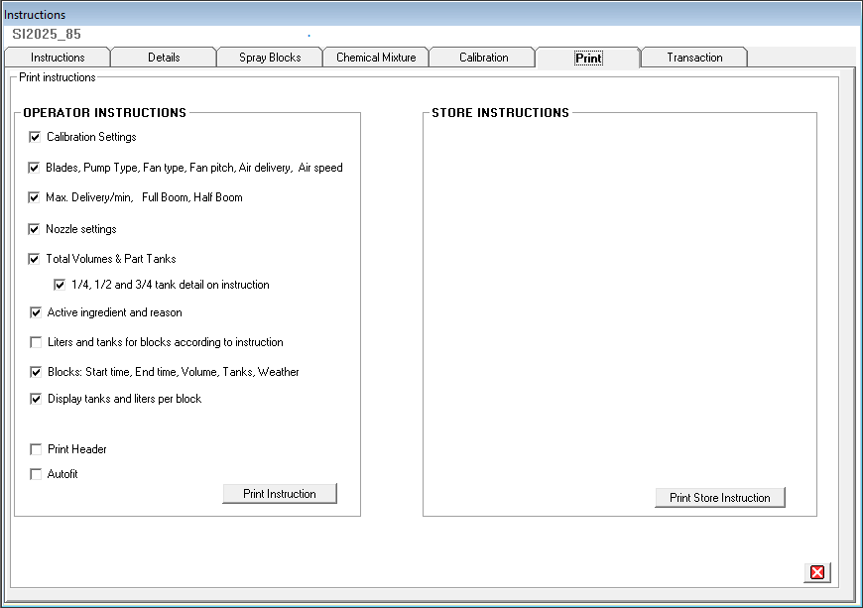

Print instructions tab:
- On this screen, you can select different options to print on your instructions. Please choose the one that best suits your needs.
- Add Page Breaks - if this option is selected, the instruction will print in multiple sections, each on a different page. Print Header, print page number and date. Autofit, to select how many pages the instruction must print.
- Click on the print instruction button (Left) to print your instructions to Excel.
- A progress bar appears at the top, which will display the printing progress.
- Store Instructions - click on the store instruction print button to print a store instruction for the store manager. This report will indicate the chemicals being sprayed and the total amounts needed for the instruction. The storeman can use this report to prepare the chemicals to be sprayed.
- Once the instruction opens in Excel, you can either print, close or edit. Remember that when you edit in Excel, it does not edit the instruction details in the Farm Management program.

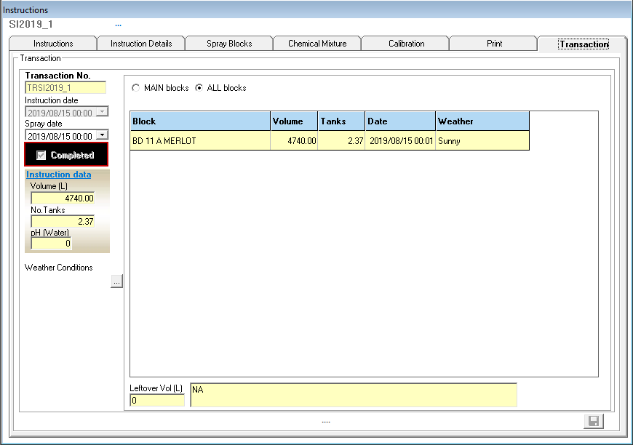

Transaction tab:
- When clicking on the transaction tab, a message will be displayed, prompting the user to confirm that the instruction will be completed. If you are ready to complete the instruction, click on yes.
- Spray date - the spray date can be changed if needed.
- The completed option must be ‘Checked’.
- Actual volumes or tanks can be edited to change the instructions, volumes, etc. If you change these values, the program will automatically adjust the chemical amounts used in this instruction.
- Weather - select the weather conditions at the time of spray. The weather will default to “Sunny”.
- Leftover Vol (L) - Enter the amount (in litres) that was leftover, if any.
- Next to leftovers, you must supply a reason why there are leftovers.
- A list of blocks for the instruction will be shown; you can either change the volume per block or tanks per block.
- You can change the spray date per block.
- If you select MAIN blocks, another screen will appear.
- On this screen, you can enter the Start- and end times for spraying each block.
- Once you are satisfied that everything is in order, you can click on save, at the bottom of the screen. Instruction completed.

- Multiple Instructions

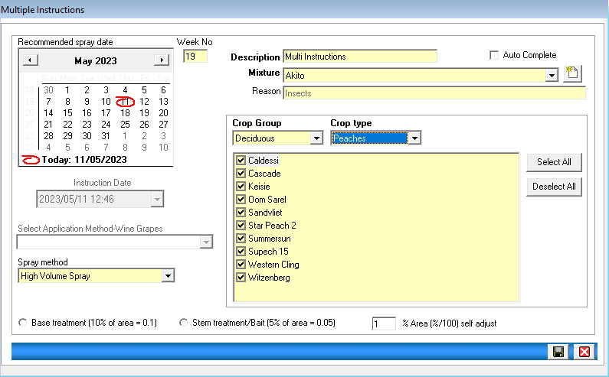

- To use the Multiple Instructions option, you will first need to set up Spray Groups by selecting the spray group icon.
- The multiple instructions will find the different crop types in the groups, and create different instructions, each with its own calibrations.
- Recommended Spray date - Select the recommended date to spray.
- Week No. will be completed automatically.
- Description - type in a description for the instruction.
- Auto Complete – this can be checked if you want to auto complete the multiple instructions later.
- Mixture - select the mixture from the dropdown list, or add a new one using the shortcut.
- Reason – this is automatically shown when the mixture is selected.
- Spray Method – automatically High-Volume Spray, can choose a concentration spray.
- Crop Group/Crop type - select crop group and type, the crop types will appear in the list to select from.
- Click on save, once you have finished.
- The screen will close, and the multiple instructions will be available by clicking on the Instruction icon.
- You can now print the instructions and complete them, when necessary, as you do with normal instructions.

- Reports

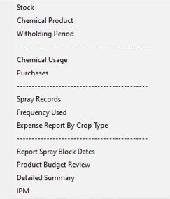

- Stock - shows the transaction history for each chemical product and the calculations for the current stock values in your store.
- Chemical Product - shows all the chemicals and their details. An option is available to build your report by checking the relevant options.
- Withholding Period - shows each chemical product, with its relevant withholding periods.
- Chemical Usage - displays a summary of transactions per product for some time.
- Purchases - displays your purchases.
- SPRAY RECORDS - shows what has been sprayed on a block for some time. Multiple Reports are available.
- Frequency Used – displays how many times a product has been used on a specific block.
- Expense Report by Crop Type – displays the spray expenses per crop type and block.
- Product Budget Review - displays all your instructions on a report to determine the total amounts used for the season, per product.
- Detailed Summary - displays totals per chemical group applied.

